MacArthur JROTC Newsletter Volume VIII
April 2021
Article and photos by: Cadet Captain Jesylin Hanza and Cadet SFC Addy Rosado
Hello Cadets! We hope you enjoyed your Spring Break and are enjoying your time back. This month was our busiest one yet with many events. On Friday March 5th we had our second Street Clean up of the school year. Good job to all of the cadets who participated! Our Snap Raise fund fundraiser came to an end Thursday March 11th. The JROTC Battalion raised $6,350. On March 12th, we hosted the first annual Battalion Dining Out. Cadets participated in a formal dinner and fun games afterwards. On March 24th, we hosted our Cadet of the 2nd Quarter. Congratulations to Cadet Corporal Kai Aguilar for winning for the Leadership Education Training (LET I) division and to Cadet Staff Sergeant John Kennedy for winning for the LET II division. On March 27th, the UnArmed Drill Team, Color Guard, and Raider Team participated in the Tulsa Union Drill Meet. The UnArmed Drill Team won 1st Place for the Regulation and Inspection Phase and the Color Guard Team won second place for Regulation. The Highlander Battalion won 2nd Place Overall.
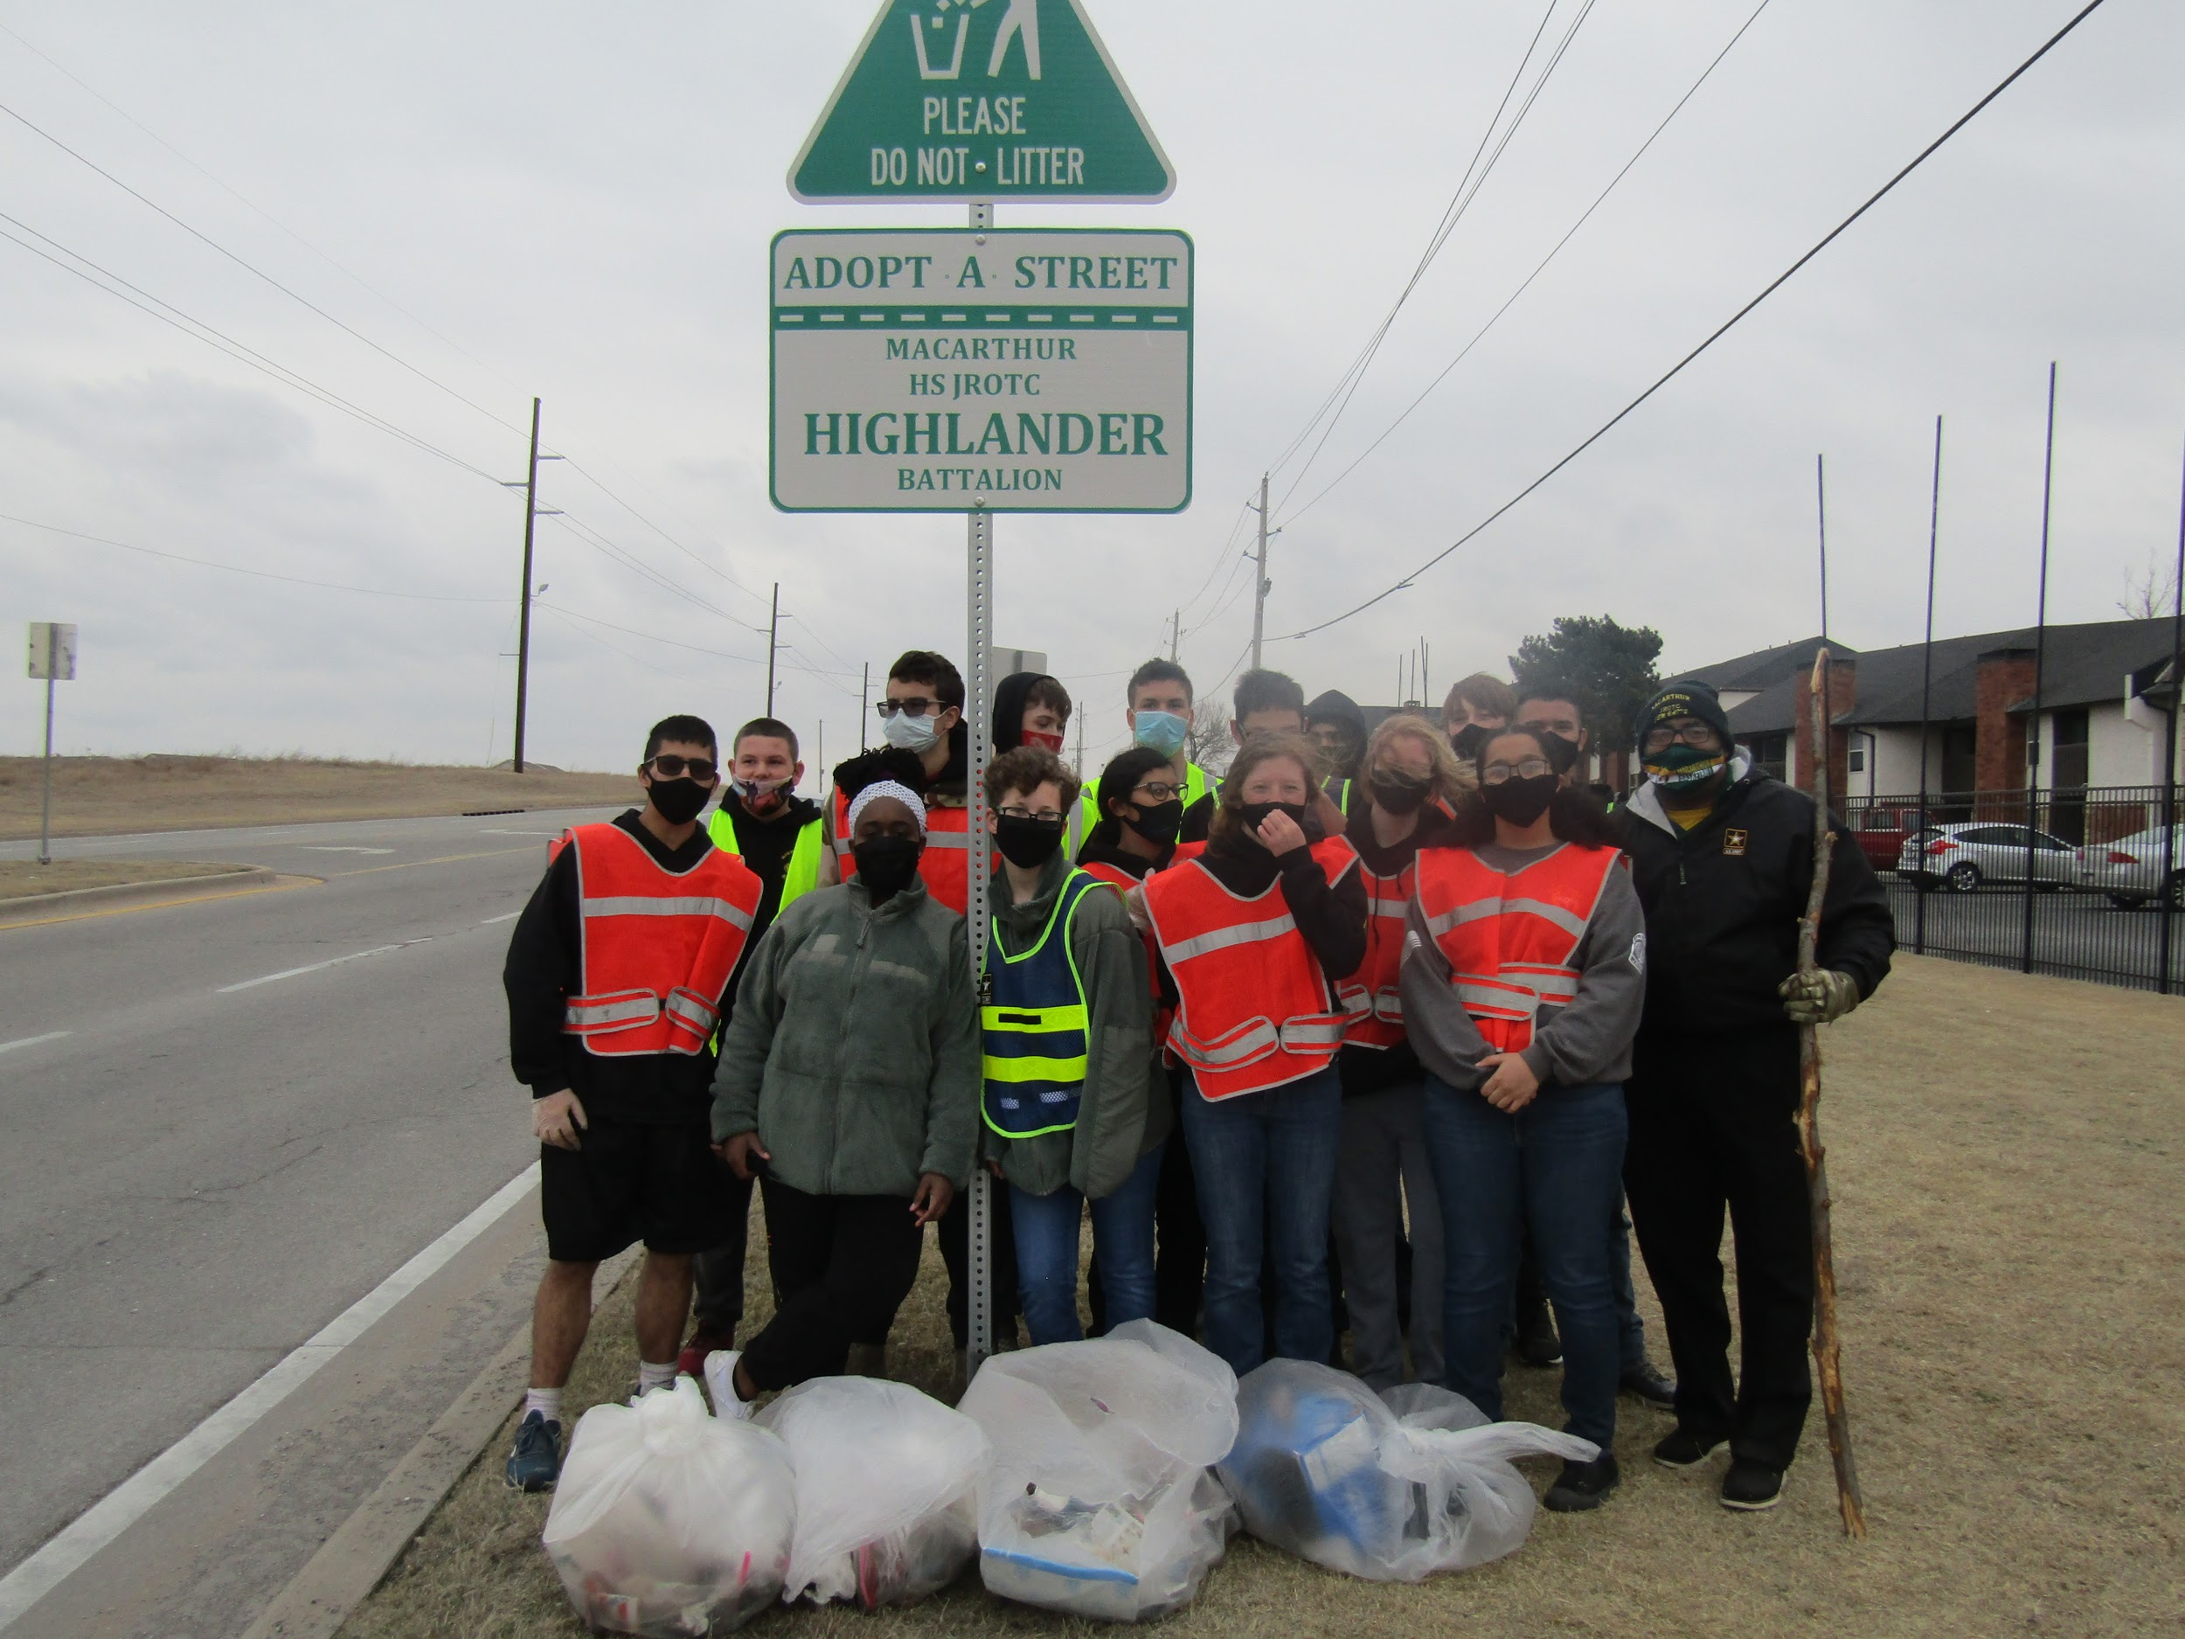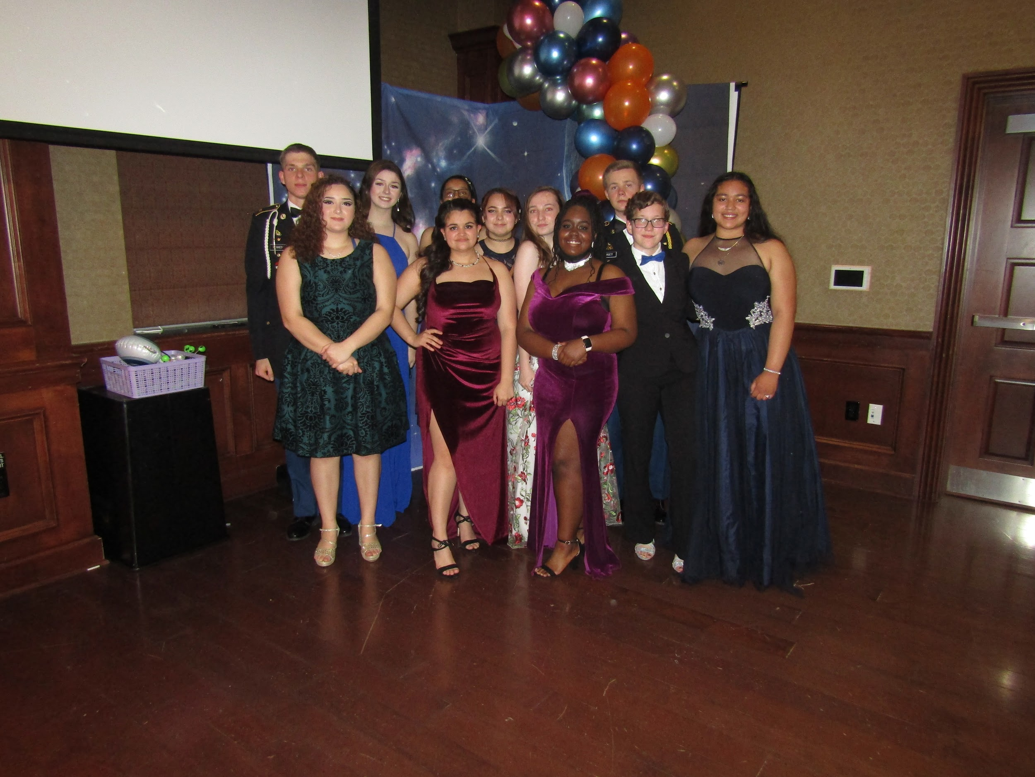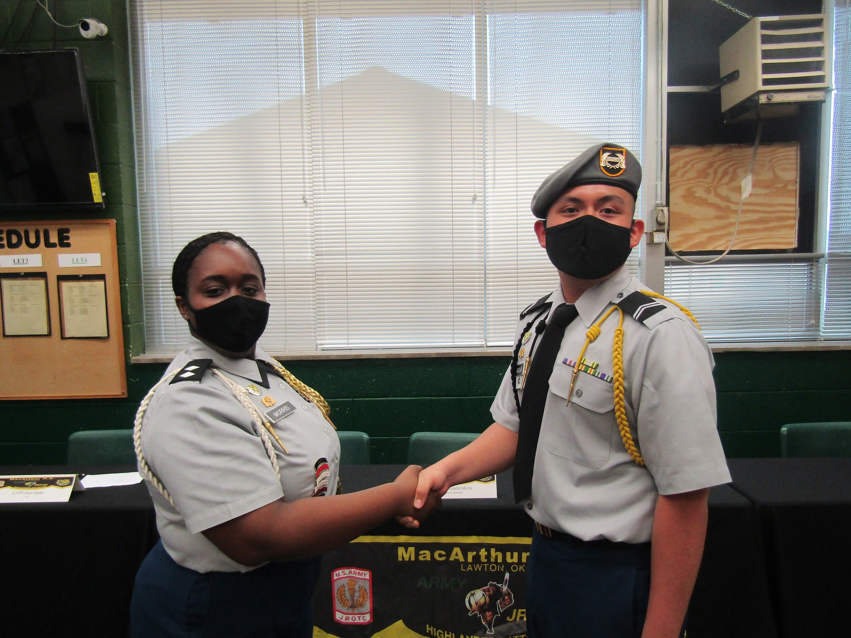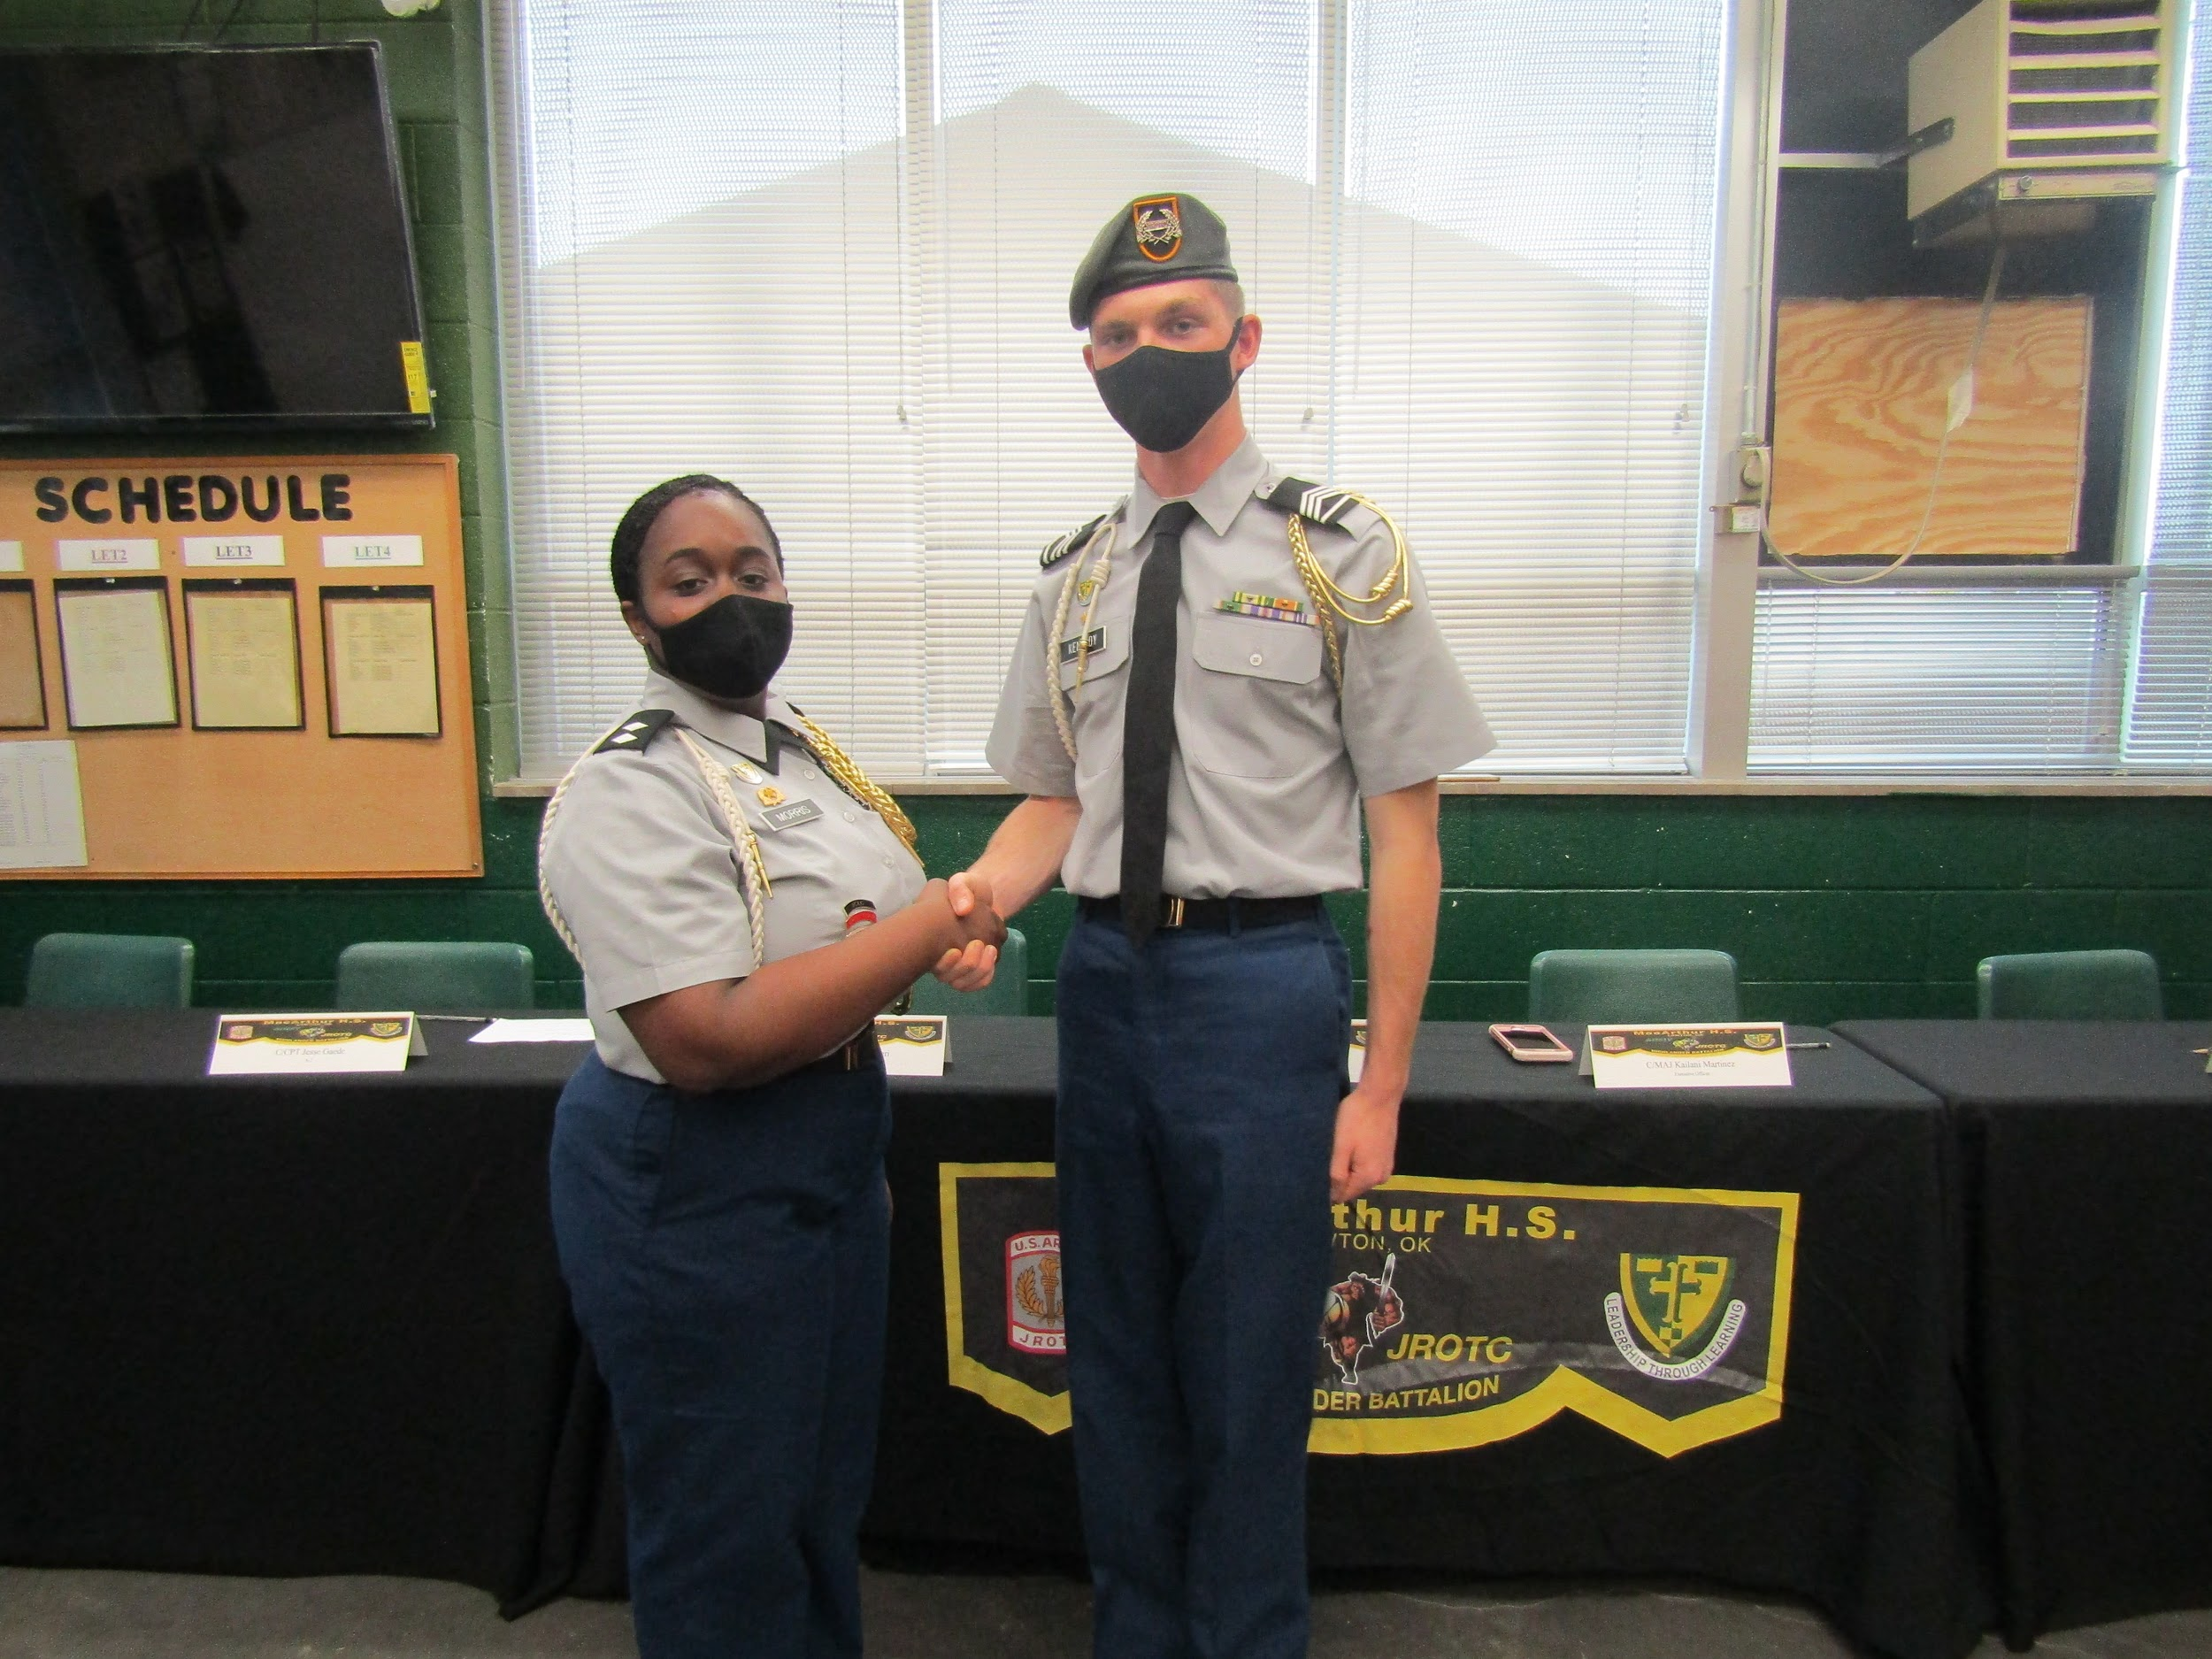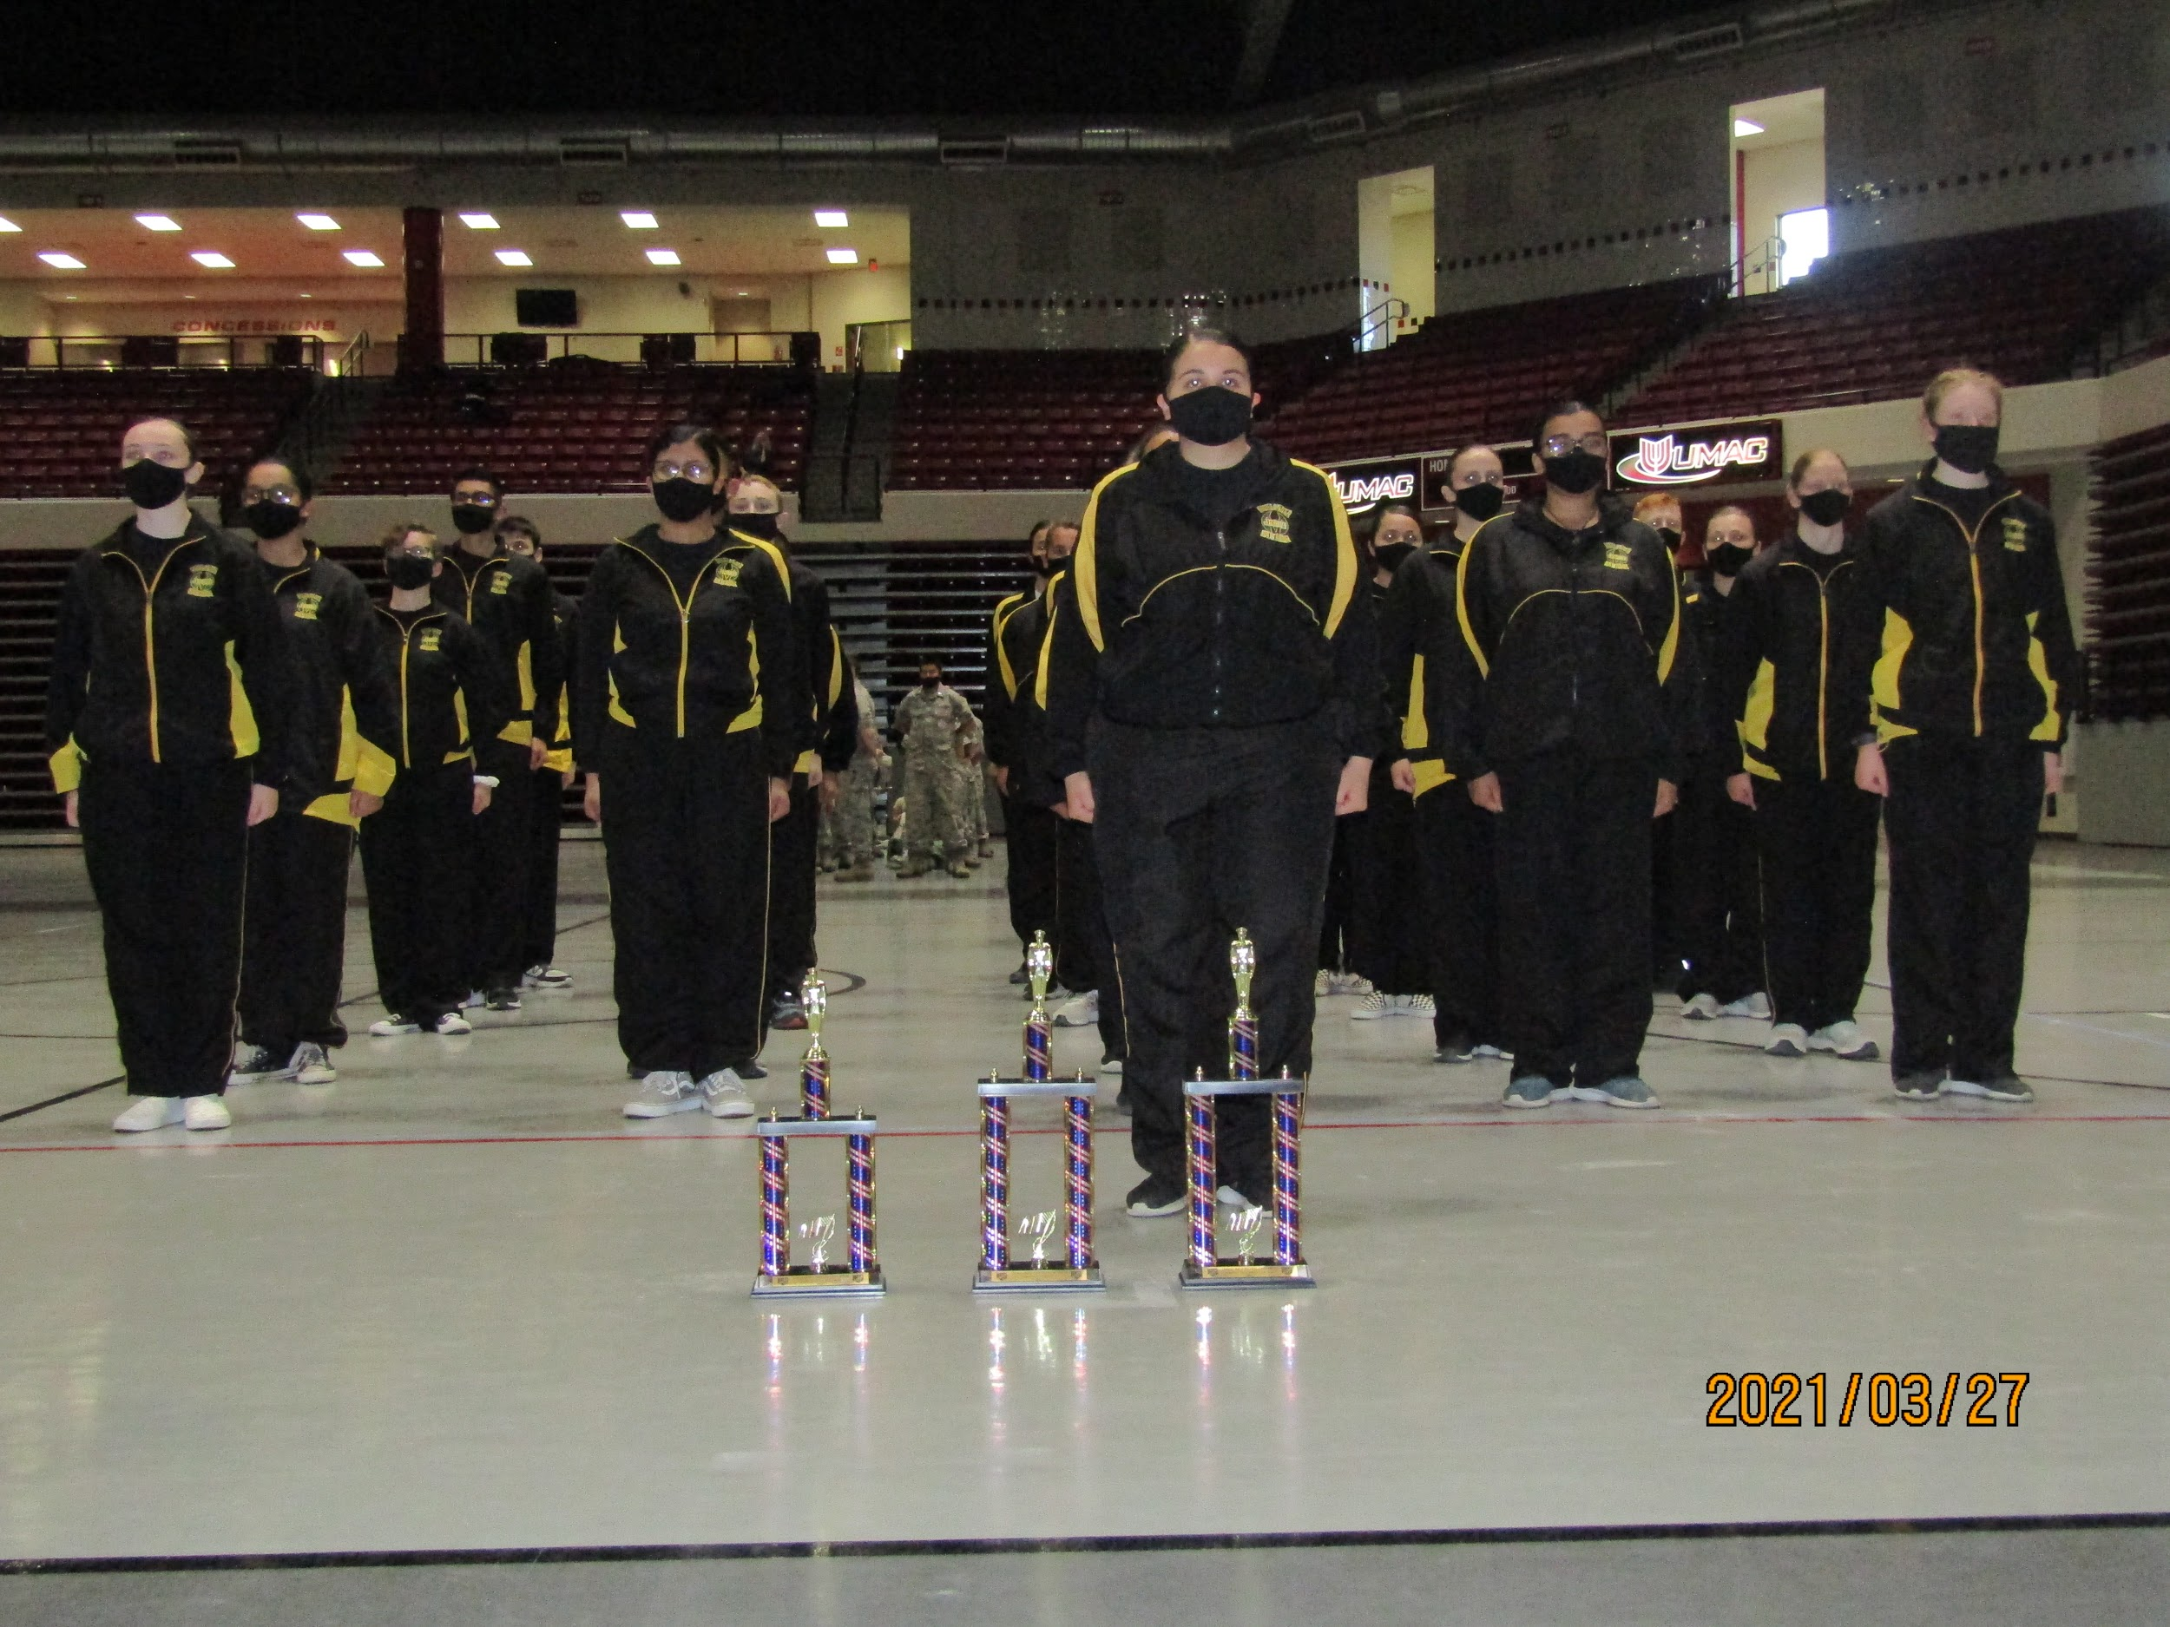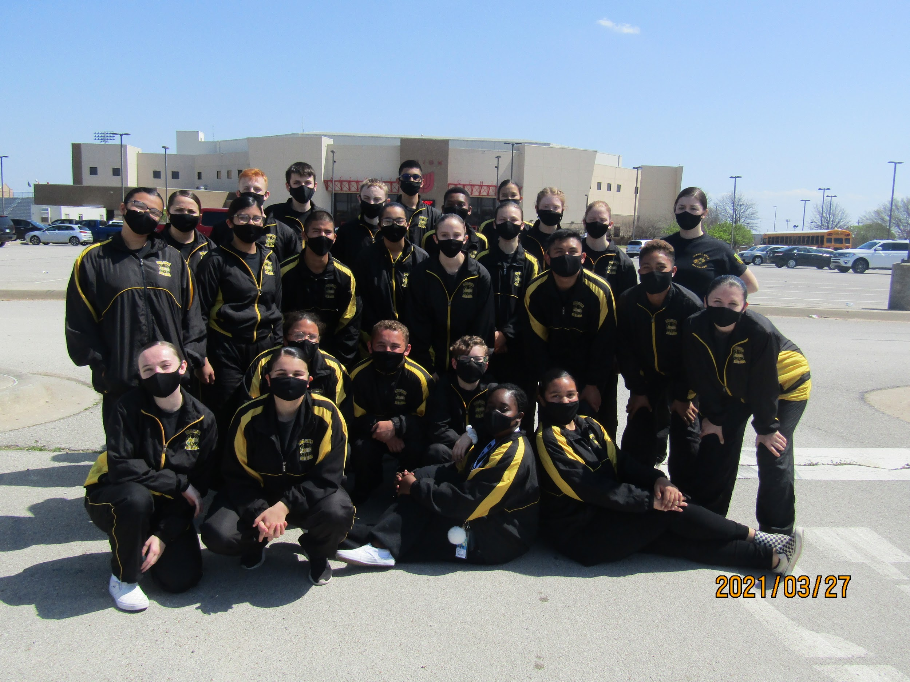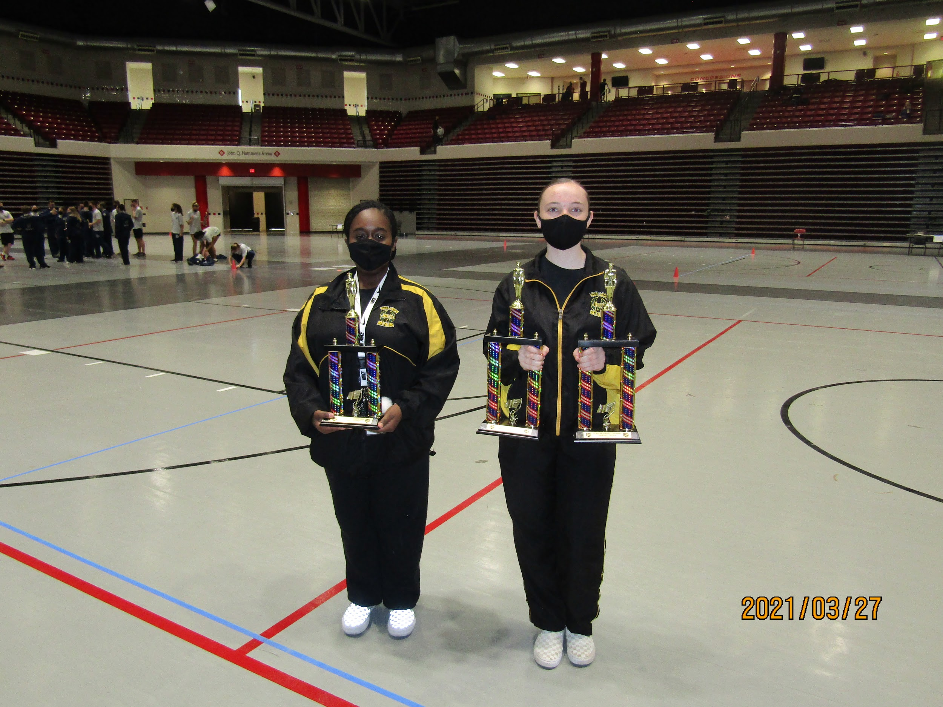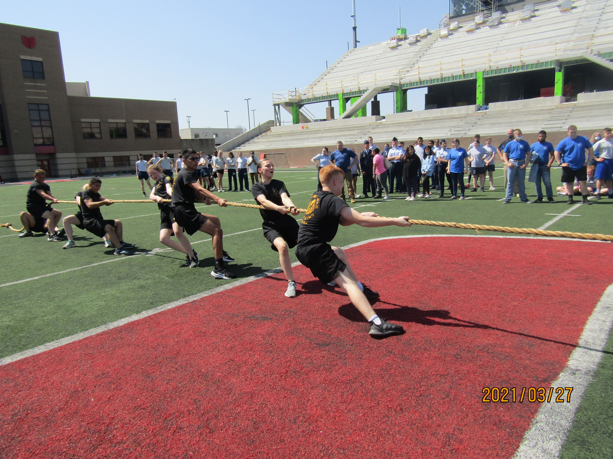
Cadet Corporal Kai Aguilar raised $1,220 during our Snap-Raise fundraiser. Cadet Aguilar was gifted with $100 for raising the most money, Congrats!
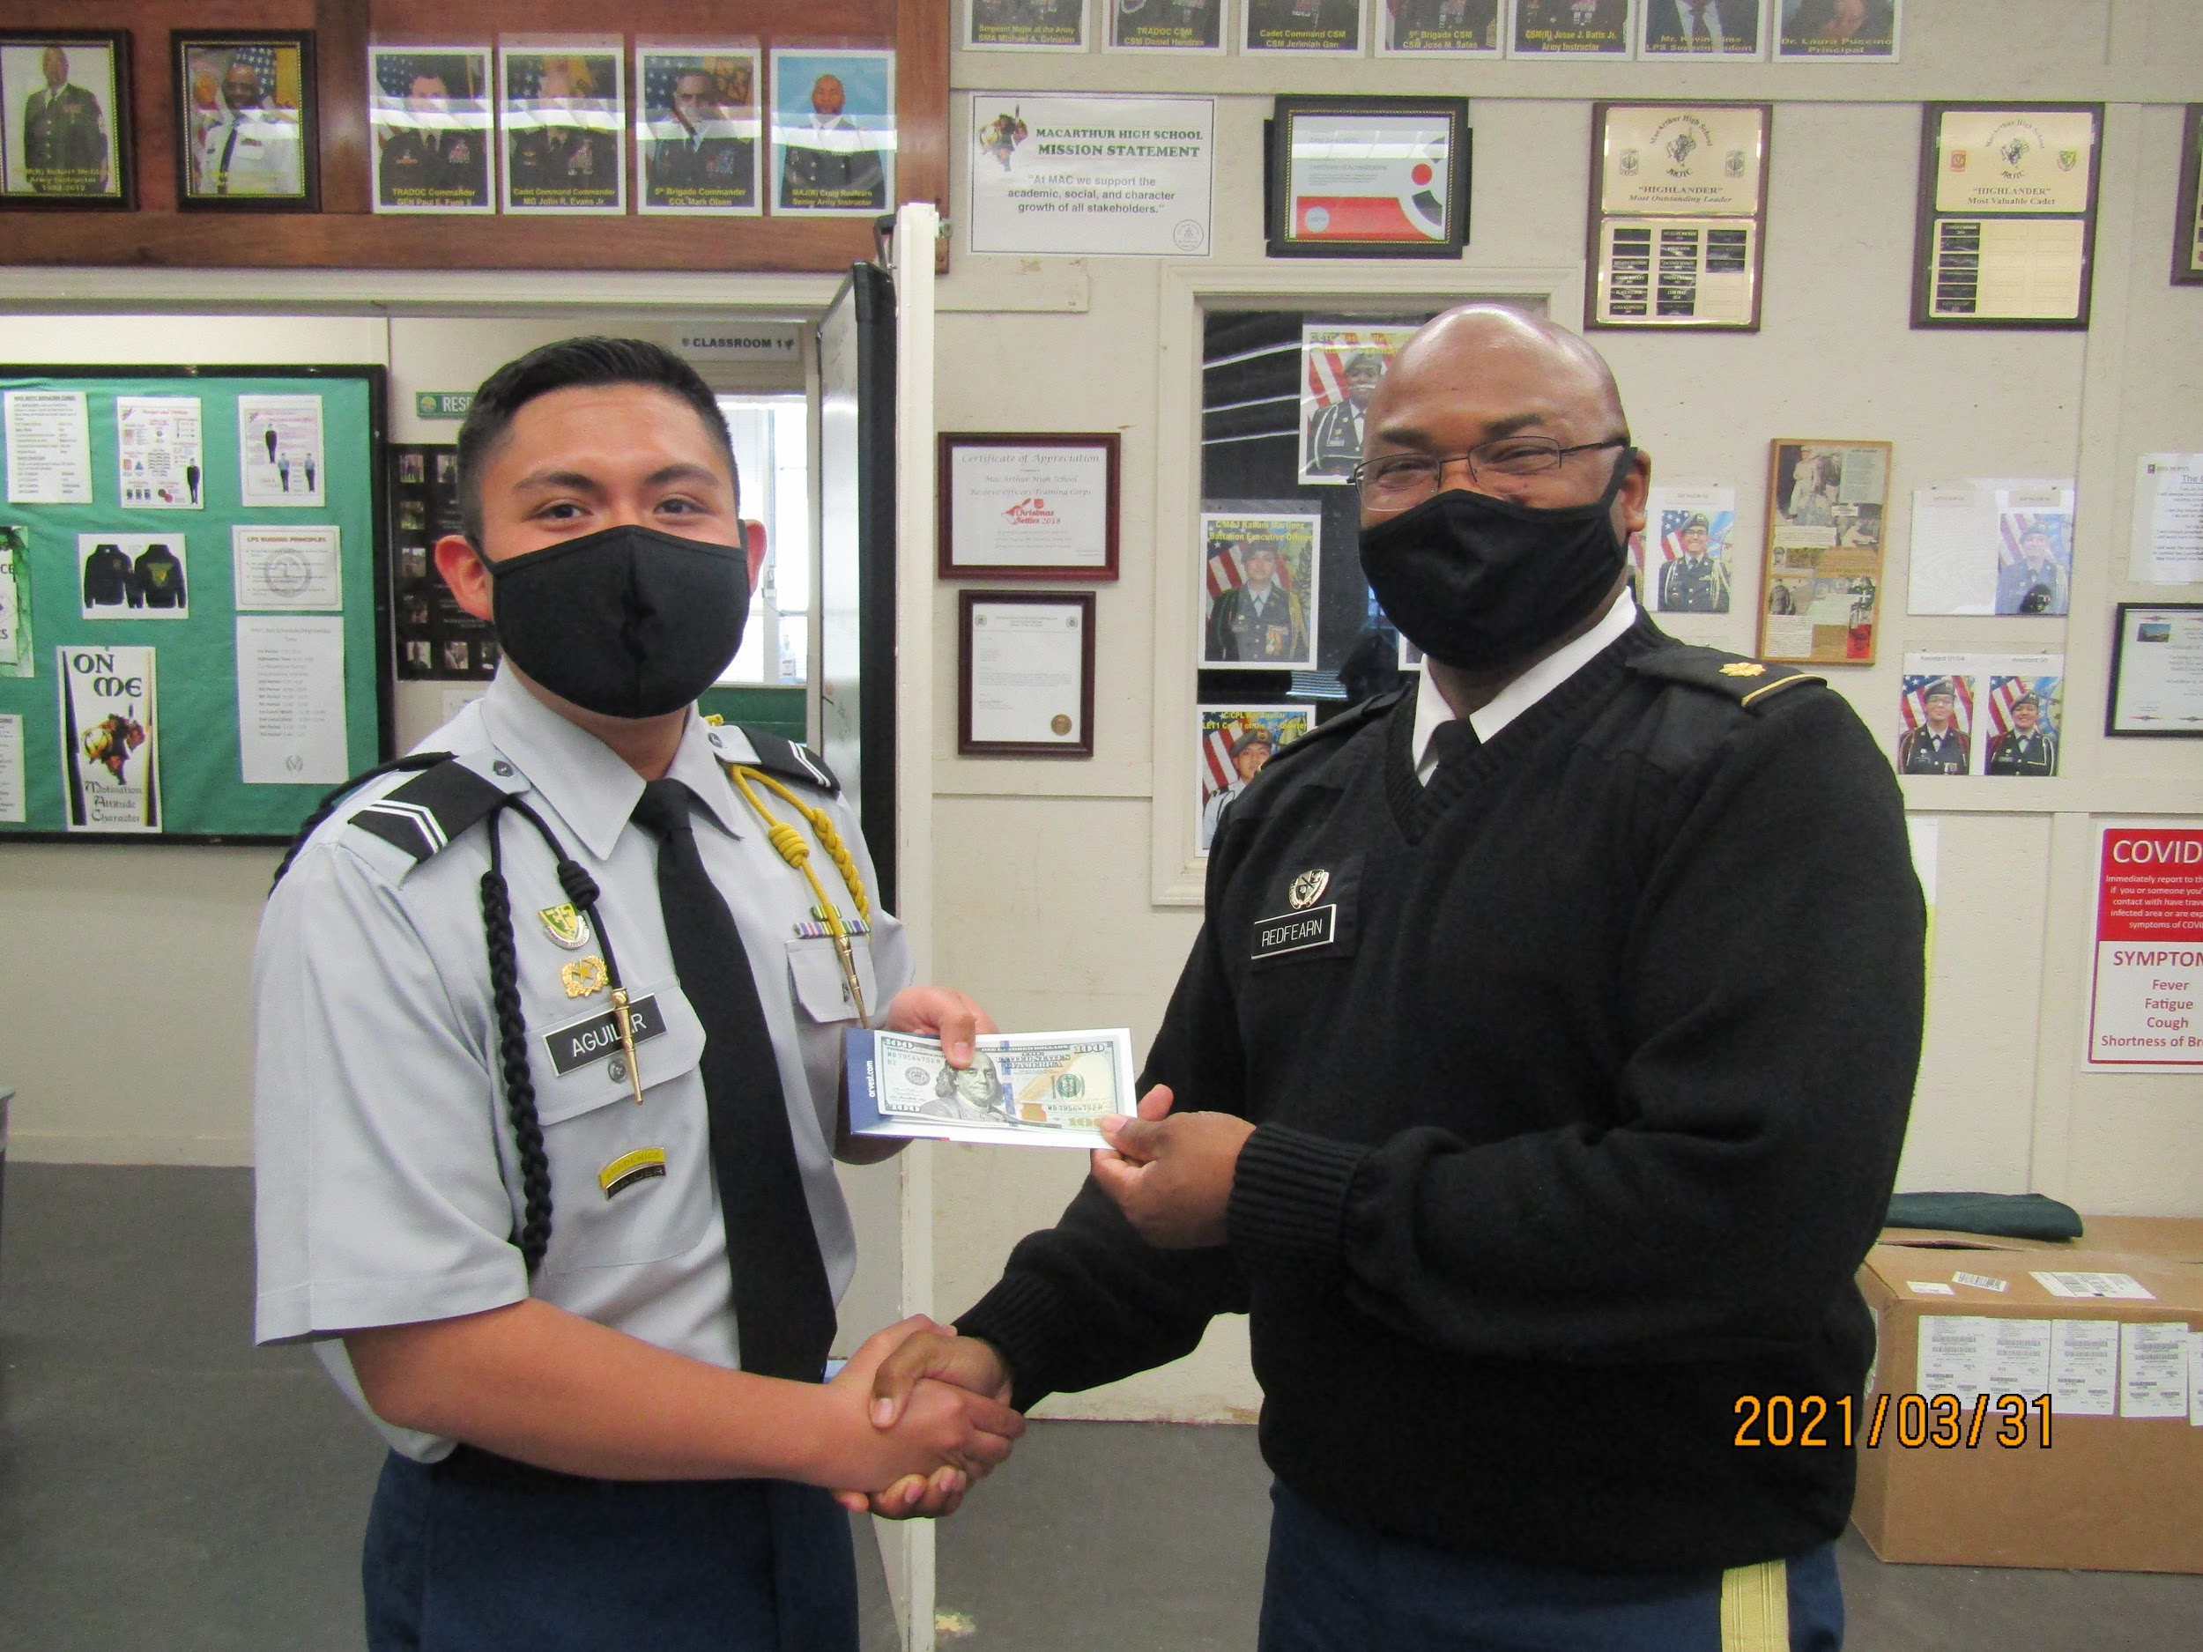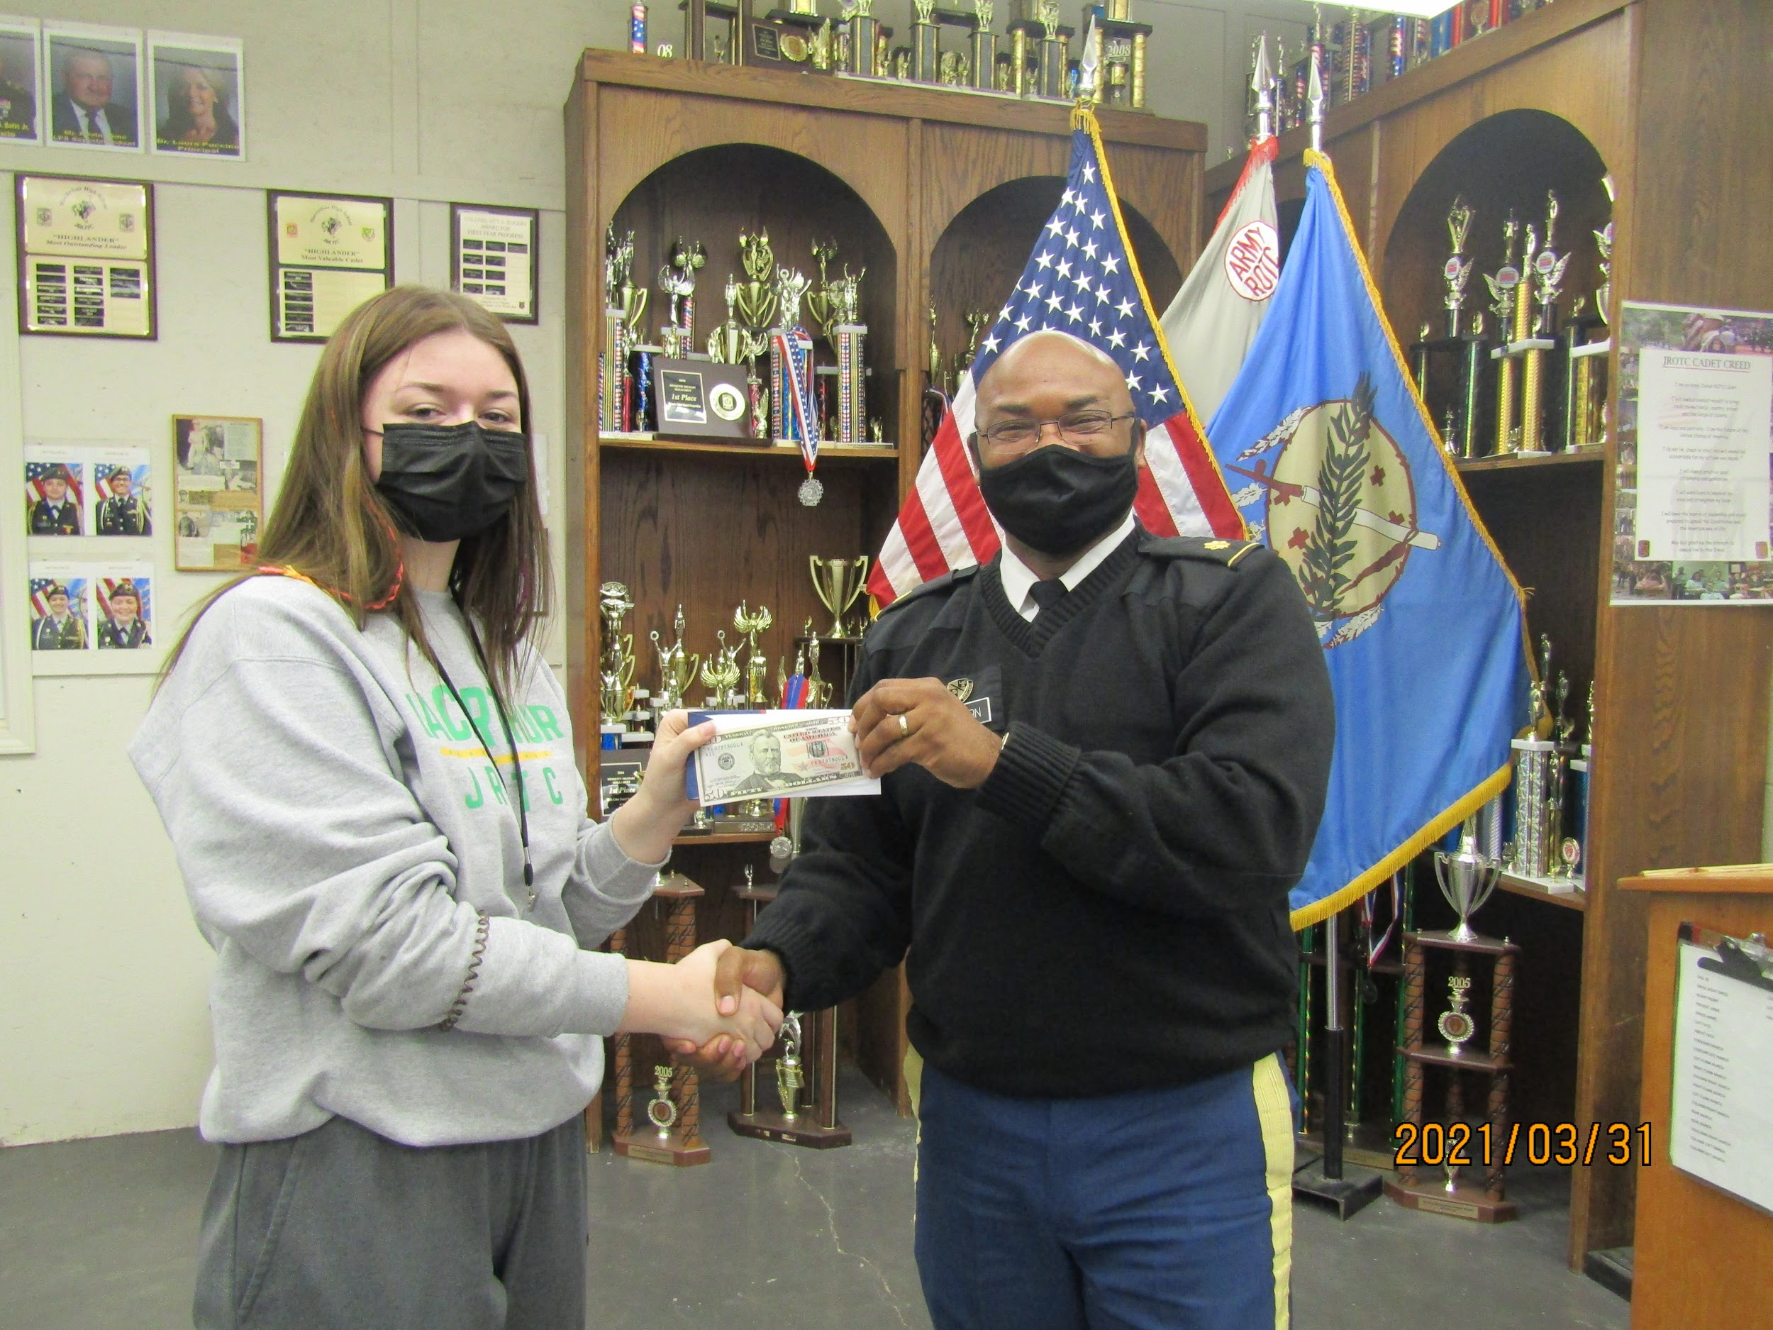
After raising $1,025 during our Snap-Raise fundraiser, cadet Captain Jeslyn Hanza’s name was put in a raffle for $50 along with all of the other cadets who raised more than $300. She won the raffle and received $50, Congrats!

Upcoming Events

Saturday April 17th 4am-8pm- Spartan Warrior PT Challenge

April 12th-16th- Cadet Challenge

Wednesday April 21st 2:45pm- Staff meeting

Wednesday April 28th 7:45am-10:30am- Awards Ceremony

Saturday May 1st 5am-5pm- Raider Team OU 5k
Saturday May 1st 6pm – 9pm- MacArthur HS All-Years Class Reunion Color Guard
Wednesday May 5th 2:45pm- Staff meeting

Saturday May 8th 11am-1pm- Street Cleanup (Community Trash-Off)

Wednesday May 19th 2:45pm- Staff meeting

