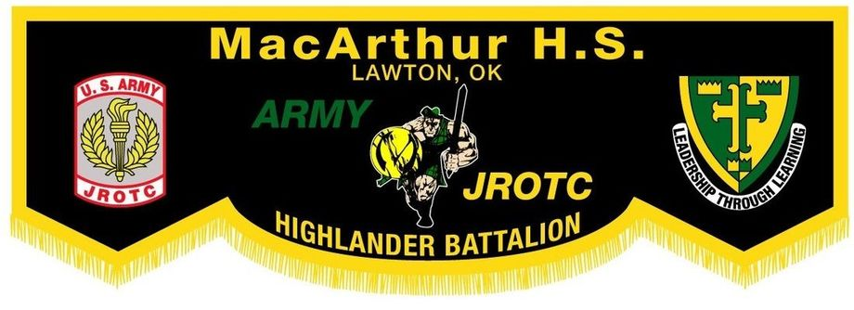
CADET OF THE QUARTER
INFORMATION
PACKET

Cadet of the Quarter Information

Questions you might have:
What kind of knowledge do you need to participate?
You will need to know the questions, current events, cadet creed, and will need at least a 3.0 G.P.A.

Where can I find the questions?
You can find the questions on the JROTC website, which is; www.macarthurjrotc.com
- Once you get to the website, you will need to click on the tab named “More.”
- Next, you will need to proceed to “Helpful Downloads and Links”
- Scroll down and look under the “Misc. Downloads” section
- Cadet of the Quarter questions will be there for you to download under the title: “Cadet of the Quarter Questions.”

What does ‘current events’ mean?
Current events mean what is important and happening now in the United States. This will be a question you will be asked by the President of the Board (The Battalion Commander).

Who can participate?
Let 1-3 may participate in the board; if requirements are met.
- During Cadet of the Quarter you do not have to worry about going against all 10 cadets. All LET1s will compete against only LET1s. LET2-3s will only compete against LET2-3s.

How do I approach the board?
Approach the door and knock three times. The Battalion Commander will say, “Enter” and you will enter the room. Once you’ve entered the room, close the door behind you. Proceed to the most direct route to get 3 steps in front of the chair. Once in front of the chair, face the Battalion Commander and report in. When you reporting in you are always at the position of attention and salute. You will say, “Ma’am, Cadet (your rank and last name) reports to the President of the board as directed.” Do not drop your salute until the Battalion Commander drops her salute. After you drop your salute the Battalion Commander will say, “The Cadet Creed” and you will recite the Cadet Creed. Upon completion of the creed, the Battalion Commander or President of the Board will give you facing movements to execute. Be prepared for movements such as left face, right face, and about face. After you have finished the facing movements the Battalion Commander will tell you to take a seat. The President of the Board will say, “Relax”. This means you will still sit at the position of attention but not too stiff. This is when you will be asked questions.

How many questions will I be asked?
You will be asked three questions from the Executive Officer, Command Sergeant Major and staff members. From the President of the board, you will be asked four questions; including the current events question.

How do I correctly announce my answer when given a question?
The correct way to answer someone on the board is by their rank. You will say their rank before and after your answer. For example:
If a board member asks, “How many stars on the U.S flag?”
You would say: “Sergeant, there is 50 stars on the U.S flag, Sergeant!”
The way you articulate words and have confidence is one way you will be successful in the board.
*Names and Rank of TOP 3 and STAFF will be placed in front of them*

What kind of awards will I get?
If you win first in your LET level, the rewards include: a certificate of achievement, a Battalion coin, a Cadet of the Quarter arc, a Principal letter, a Commendation Ribbon, a Cadet of the Quarter ribbon, and 250 promotion points (an additional 150pts for winning). If you do not win, you will only receive 100 promotion points.
What will I be graded on?
You will be graded on your appearance, bearing, articulation of words, your haircut and bun (females only), sharpness, and knowledge of questions.

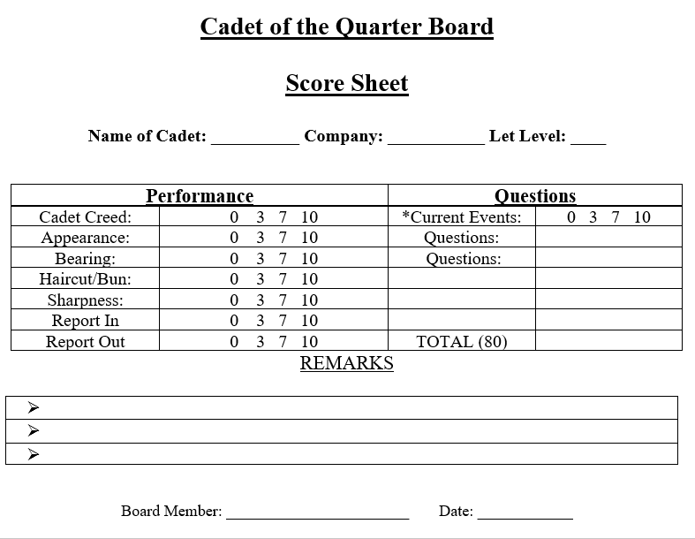
What happens if I do not show up to the board and I volunteered?
If you do not show up to the board without complete verification saying you are exempt, consequences will enable. The consequences will result in a zero for leadership that week and 100 promotion points taken away. The only way you can be exempt from this is if you talk to CSM or MAJ beforehand on the reason why you cannot participate in the board or won’t be there.

How do I exit the Cadet of the Quarter board?
After the Battalion Commander asks you to stand, you will report out. Before you report out you will need to salute the Battalion Commander. When reporting out you will need to say: “Ma’am, Cadet (your rank and last name) requesting permission to leave the Quarter board, Ma’am”. Do not drop your salute until the Battalion Commander drops theirs. Once the salute is dropped you will need to take two steps forward, about face, and immediately after that say, “HIGHLANDERS” Once that is finished proceed to the most direct route to the exit with your CMDR or 1SG. After you have completed the board if you have any suggestions whatsoever on how the board could run any better please leave a note with your name on how it can run smoother. Place into the Command Sergeant Major’s inbox located on the opposite wall of the water fountain.

After I have finished participating in the board where do I go?
After your turn has finished and you exited the room, you may proceed into the formation area. You are not allowed to talk to your other competitors. You will need to wait until everyone else in your LET level has finished. After everyone has participated, the Command Sergeant Major or a board member will ask everyone to enter the room one more to time to announce the winner of the board.

If I do not win, can I participate again?
If you do not win, you may participate again. Although, you can participate, the cadets who have not participated will have priority. If you win the board, you may not participate in until the following year.

“###”=ONLY LET 1 Questions
“>>>”=ONLY LET 2-4 Questions
****= Any LET Level
###Q: The right to keep and bear arms is guaranteed by which amendment in the Bill of Rights?
A: The second Amendment
###Q: Define the term “followership.”
A: Knowing how to act as a member of a team.
>>>Q: What are the three ways to stop bleeding?
A: Pressure bandage, pressure points and tourniquet.
>>>Q: What is the name of the congressional act that launched the JROTC program?
A: National Defense Act of 1916
###Q: When did Congress pass the ROTC vitalization Act?
A: 1964
###Q: What are the two primary political parties?
A: Republican Party and Democratic Party
>>>Q: What war was fought during the 1960’s and 1970’s?
A: The Vietnam War
>>>Q: What war accounted for the most American Casualties?
A: The U.S. Civil War
###Q: Who was the commander of the revolutionary Army?
A: George Washington
###Q: How many stars are on the U.S. flag?
A: 50
>>>Q: What are the five major terrain features?
A: Hilltop, Ridgeline, Saddle, Valley, and Depression
>>>Q: What are the colors of the flag and what do they stand for?
A: White- purity, Blue- Vigilance & Perseverance, Red-Hardiness & Valor
###Q: What are two ways to obtain U.S citizenship?
A: By naturalization or birth.
###Q: T or F: A tourniquet should be used immediately to stop arterial bleeding.
A: False a Tourniquet is only used as a last resort.
>>>Q: Define the term “Drill”
A: Movements by which a unit is moved in a uniform manner from one formation to another or from one place to another.
>>>Q: What are the most common units of measurement on the bar scale of a topographic map?
A: Miles, Meters, and yards
###Q: In the U.S. Senate, each state has_______ representatives?
A: Two
###Q: Drill teaches cadets?
A: Discipline
>>>Q: An ______ contour line is a heavily drawn line, with its elevation usually given.
A: Index
>>>Q: What is one of the main uses of barbiturates by medical personnel?
A: To reduce the Frequency of convulsions in epileptics.
###Q: Give a common type of capillary bleeding.
A: Nosebleeds
###Q: T or F: Freedom of religion is guaranteed by the second amendment.
A: False Freedom of religion is guaranteed by the first amendment.
>>>Q: Define the term “shock.”
A: The failure of the cardiovascular system to keep adequate blood flowing to vital organs such as the brain, heart, or lungs.
>>>Q: A ___________ is a dip or a low point between two points of high grounds.
A: Saddle
###Q: The feeling of pride and unity that is fostered by working in a team is called_?
A: Esprit de corps
###Q: When is the flag flown at half-mast?
A: The flag is flown at half-mast in times of distress or emergencies.
>>>Q: What type of amphetamine produces immediate addiction which is extremely resistant to any type of therapy?
A: Crack cocaine.
>>>Q: What is a contour line?
A: Lines on a map that connect equal points of elevation.
###Q: A_____ represents an imaginary line on ground, above or below sea level.
A: Contour line
###Q: T or F: When a flag is flown at half-staff, it is raised to the peak of the flag-pole and then lowered to half-staff.
A: True
>>>Q: High cholesterol leads to an increased risk of what?
A: Heart disease
>>>Q: Directing, participating, and delegating are three basic styles of ______?
A: Leadership
###Q: What important addition was made to the U.S. Constitution in 1789?
A: The Bill of Rights
###Q: When executing a column right as a squad member in column formation, where do you pivot?
A: At approximately the point when the quad leader pivoted.
>>>Q: Define the term “dehydration”.
A: The condition that results when fluids are lost from the body and are not replaced.
>>>Q: When are the commands “eyes right” and “ready, front” commonly used?
A: During ceremonies or when passing the Colors.
###Q: The Preamble of the U.S. Constitution starts with the words ______.
A: We the people of the United States, in order to form a more perfect union …
###Q: Does a squad normally march in a column or in line?
A: In a column
>>>Q: Considering the seven communication skills, which skill precedes all others?
A: Thinking
>>>Q: What is a bridge map?
A: A bridge map is a tool used for seeing analogies.
###Q: Name the three basic principles of leadership.
A: Be responsible, set the example, and show confidence.
###Q: What are two basic steps used in marching?
A: The 30-inch step and the 15-inch step.
>>>Q: In leadership, _______ gives others a reason for why they should do something.
A: Purpose
>>>Q: Define the term “maneuver”
A: To perform a movement in military tactics (or in drill).
###Q: While at parade rest, where are your hands?
A: Centered behind your back on your belt.
###Q: When you are with a senior officer, you should walk or ride on which side of the officer?
A: The left side
>>>Q: What type of map is most commonly used by the military?
A: Topographic
>>>Q: What is the “center hold” technique used for?
A: It is fastest and easiest way to measure a magnetic azimuth.
###Q: Most commands have two parts. What are the two parts of most drill commands?
A: The preparatory command and the command of execution.
###Q: The federal court system falls under which branch of the government?
A: The judicial branch.
>>>Q: Define first aid.
A: The first medical aid given an accident victim before professional medical help arrives.
>>>Q: When does a squad leader use the command “incline around”?
A: When there is an obstacle in the line of march.
###Q: To be responsible, to set the example, and to show confidence are the three basic principles of_____________.
A: Leadership
###Q: The Bill of Rights was added to the constitution in what year?
A: 1789
>>>Q: The three branch division of power in the U.S. government is known as what?
A: The separation of power
>>>Q: When supplementary commands are necessary, the leader allows how many counts between the preparatory command and the supplemental command?
A: One count.
###Q: The judicial branch is also known as what?
A: Federal court system
###Q: When a leader ______, he or she gives another team member the authority to represent or act on the leader’s behalf.
A: Delegates
>>>Q: When a flag is used over a casket, the union is at the head and over which shoulder?
A: Left
>>>Q: What is the characteristic of capillary bleeding?
A: A slow flow of blood.
###Q: The command “forward, march” automatically means you use the ______ step.
A: 30 inch step
###Q: A cadet salutes the flag when it comes within _______ steps of the unit.
A: Six
>>>Q: What is the definition of rank?
A: The definition of rank is a single line of men one by side the other.
>>>Q: How many steps does each squad take in “close ranks, march”?
A: 1st Squad takes four half steps back, 2nd Squad takes two half steps back, 3rd Squad stands fast, and 4th Squad take two half steps forward.
###Q: Who wrote the “Star-Spangled Banner”?
A: Francis Scott Key
###Q: When a cadet is “at ease” or “at rest”, which foot must remain place?
A: The right foot
>>>Q: What is a Halyard?
A: A rope or tackle used for raising and lowering the flag
>>>Q: What are the three types of flags?
A: Post, Garrison, and Storm are the three types of flags.
###Q: What are three parts of oral communications?
A: The introduction, body, and conclusion.
###Q: Define the term “endurance”.
A: The ability to continue through difficulties such as pain, stress, or fatigue.
>>>Q: When is the Garrison flag flown?
A: On holidays and/or special occasions
>>>Q: What is the size of the Post flag?
A: The size of the Post flag is 10 x 19 feet.
###Q: Preparatory commands are repeated how many times by subordinate leaders?
A: Only once
###Q: T or F: A majority vote in the House of Senate is needed for an amendment to be proposed.
A: False. It requires a 2/3 vote.
>>>Q: What are the seven Army values?
A: The seven Army values are loyalty, duty, respect, selfless service, honor, integrity, and personal courage.
>>>Q: What is the cadence of “double time, march”?
A: The cadence of “double time, march” is 180 steps per minute.
###Q: The first 10 amendments to the U.S. Constitution are known as what?
A: The Bill of Rights
###Q: ____ is the process of planning, organizing, coordinating, directing, and controlling resources?
A: Management.
****Q: Define “Character”
A: A person’s inner strength is the definition of character.
****Q: What is a neglected communication skill?
A: Listening is a neglected communication skill.
****Q: In leadership, _____ gives others the knowledge to complete a task.
A: Direction
****Q: What are the three leadership styles?
A: The three leadership styles are delegative, participative, and authoritative.
****Q: What are the four winning colors?
A: Builder, Relator, Planner, and Adventurer are the four winning styles.
****Q: How many general orders of the Army are there?
A: There is three general orders of the Army.
****Q: What is the first general order of the Army?
A: The first general order of the Army is the saying, “I will guard everything within the limits of my post and quit my post only when properly relieved”.
****Q: What is the second general order of the Army?
A: The second general order of the Army is the saying, “I will obey my special orders and perform all my duties in a military manner”.
****Q: What is the third general order of Army?
A: The third general order of the Army is the saying, “I will report violations of my special orders, emergencies, and anything not covered in my instructions, to the commander of the relief”.
****Q: What are the colors of a Builder, Relator, Planner, and Adventurer?
A: The color brown is for a Builder, blue is Relator, green is Planner, and red is for an Adventurer.
****Q: Who is your Battalion Commander and their rank?
A: The Battalion Commander is Cadet Lieutenant Colonel Laeyyah Ginn.
****Q: Who is your Battalion Executive Officer and their rank?
A: The Battalion Executive Officer is Cadet Major Selicia DuBose.
****Q: Who is your Battalion Command Sergeant Major and their rank?
A: The Battalion Command Sergeant Major is Cadet Command Sergeant Major Anna Colburn.
****Q: Who is your Battalion Adjunct Officer (S1) and their rank?
A: The Battalion Adjunct Officer is Cadet 2nd Lieutenant Essa Wise.
****Q: Who is your Battalion Security Officer (S2) and their rank?
A: The Battalion Security Officer is Cadet Private First Class Gohan Rivera
****Q: Who is your Battalion Operations & Training Officer (S3) and their rank?
A: The Battalion Operations & Training Officer is Cadet Sergeant Aguilar.
****Q: Who is your Battalion Logistics & Supply Officer (S4) and their rank?
A: The Battalion Logistics & Supply Officer is Cadet Sergeant Reigne Riboroso.
****Q: Who is your Battalion Public Relations & Historian Officer (S5) and their rank?
A: The Battalion Public Relations & Historian Officer is Cadet Sergeant Daichele Haynes

