MacArthur JROTC Newsletter
February 2021
Article and photos by: Cadet Captain Jeslyn Hanza and Cadet SFC Addy Rosado
Hello Cadets! We hope you are enjoying the new semester thus far. We have done many color guard performances this past month. 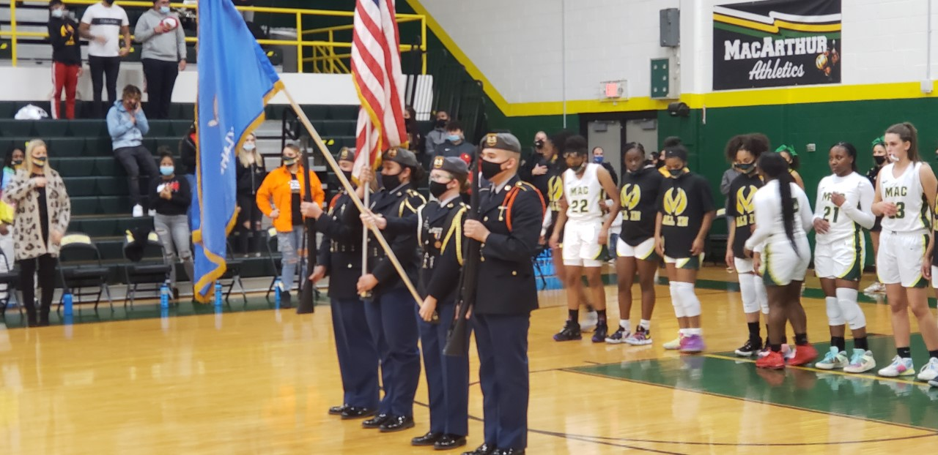 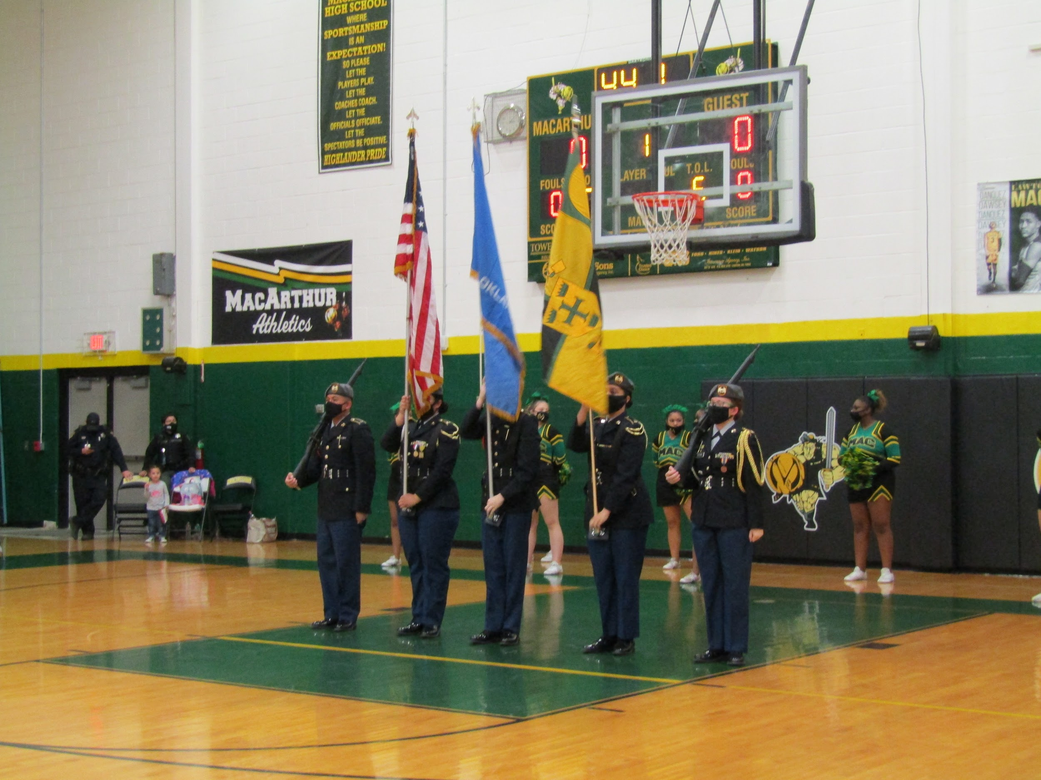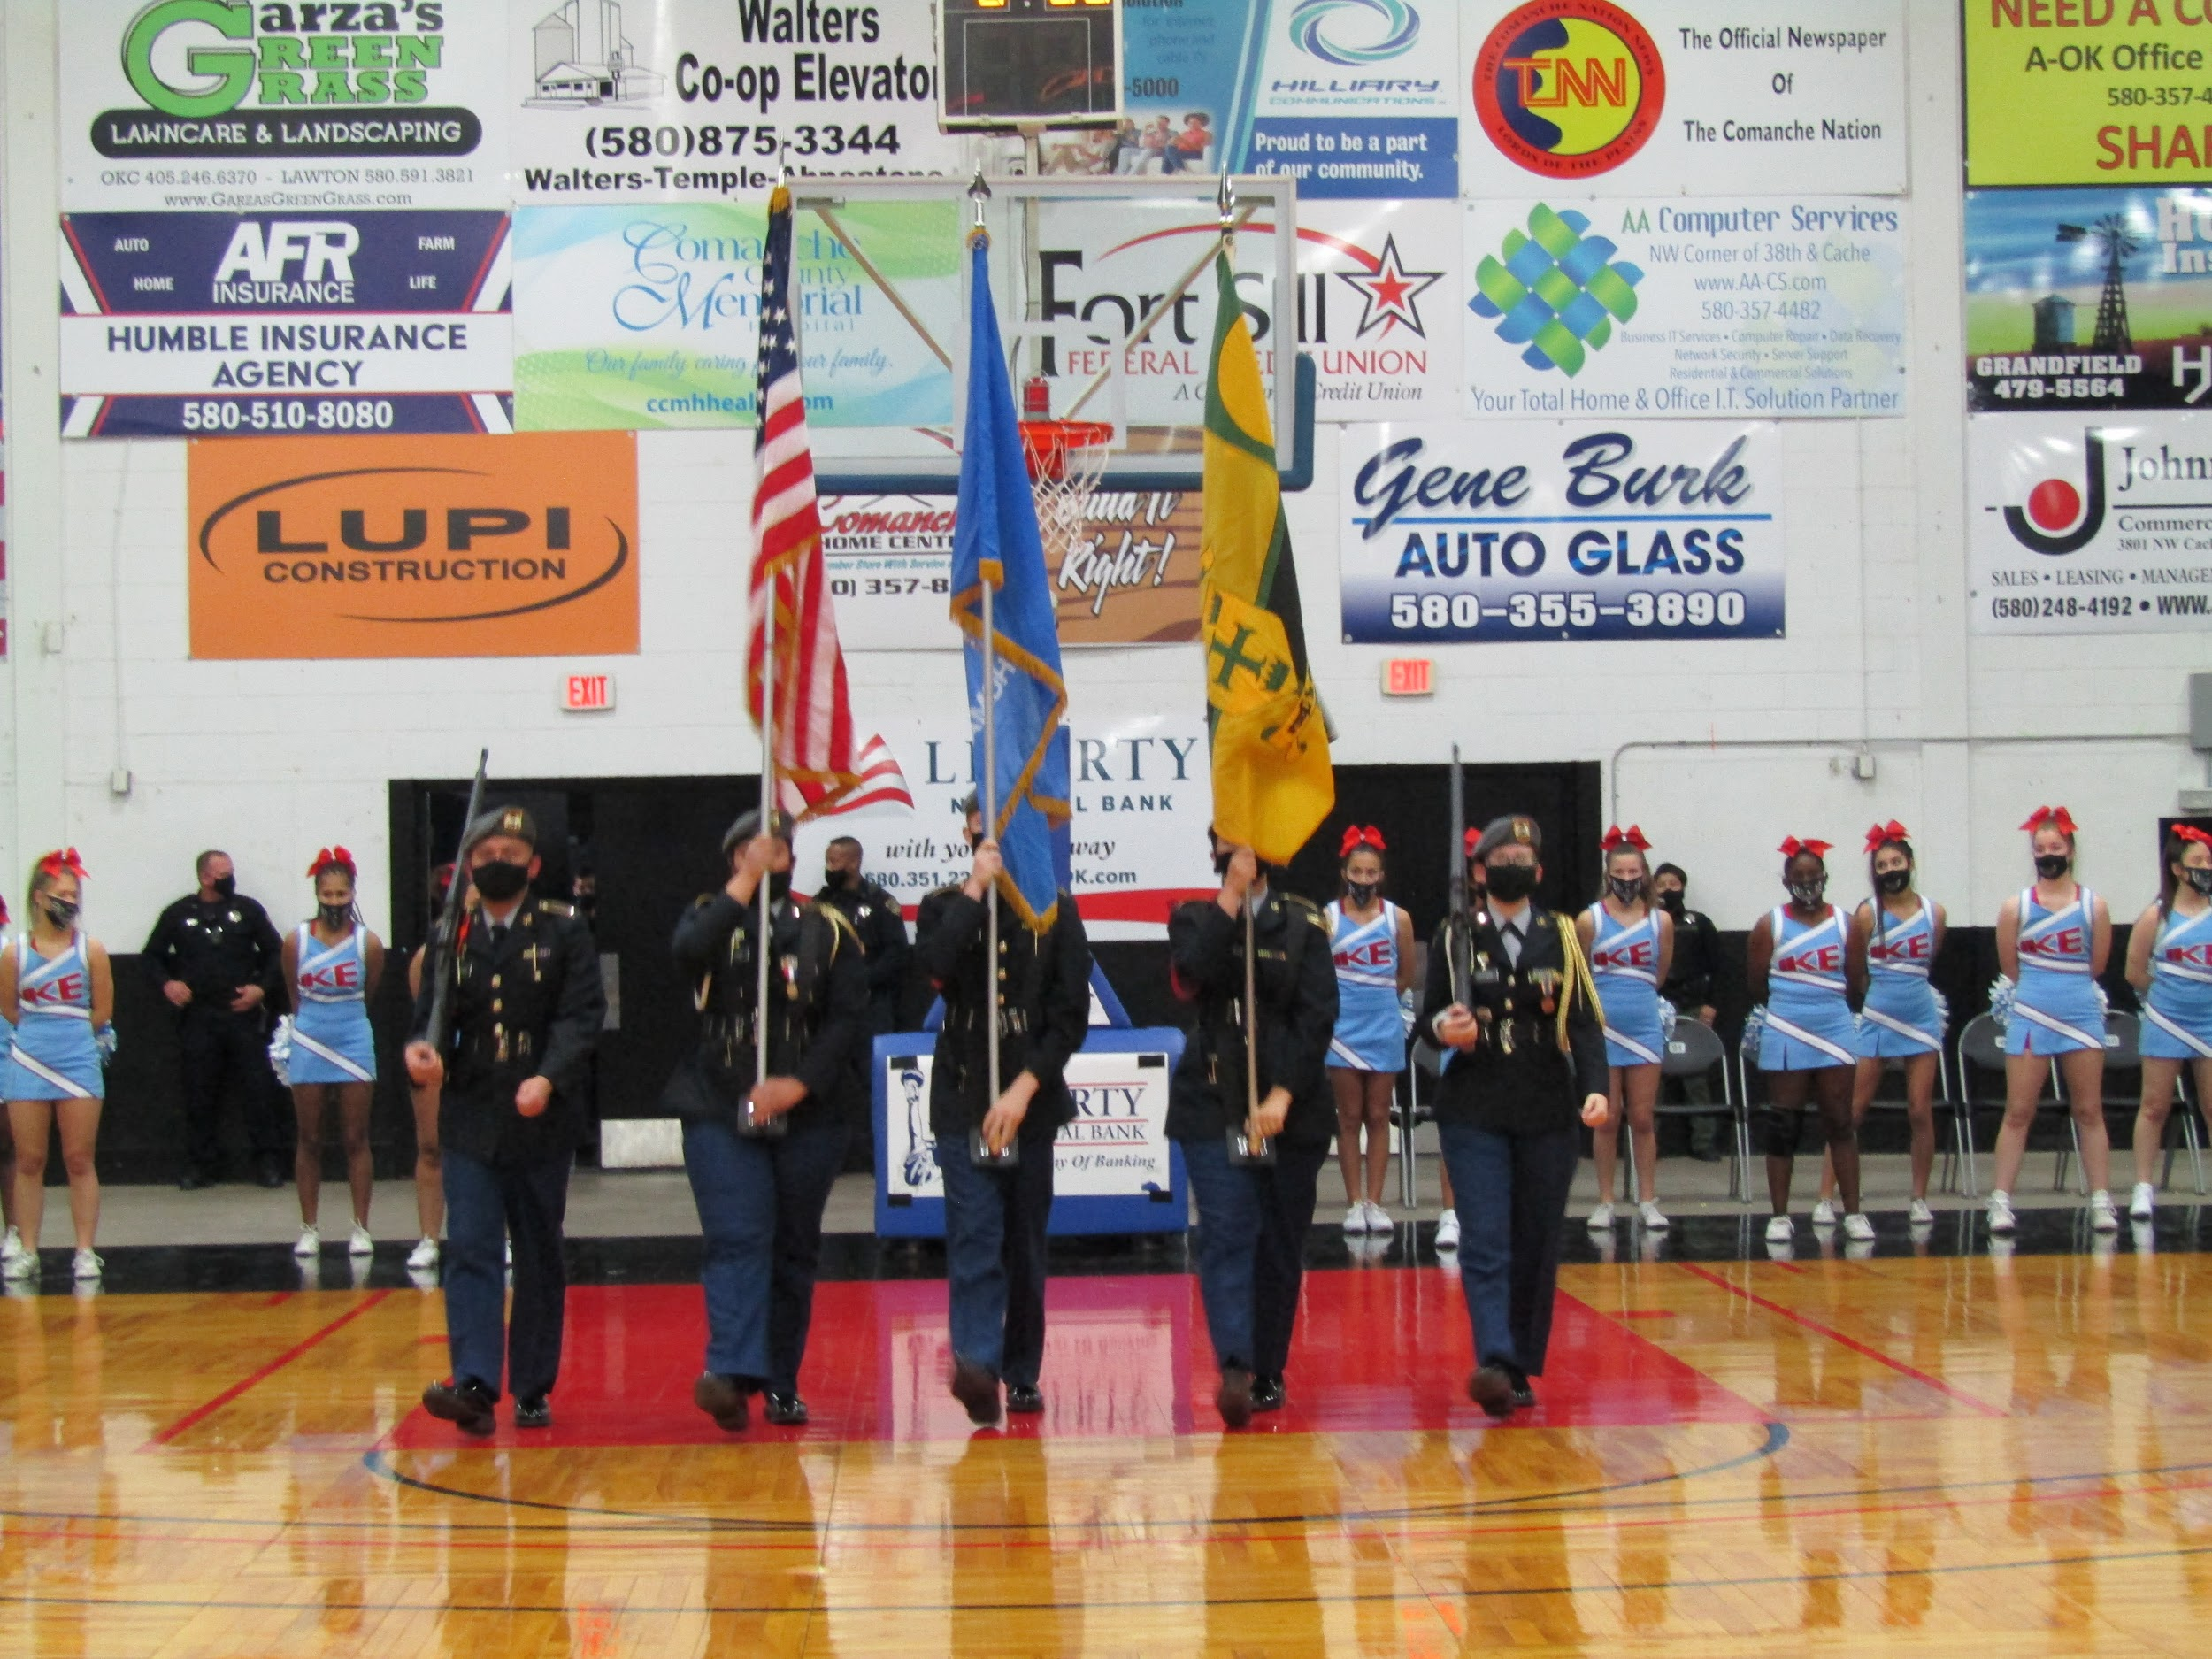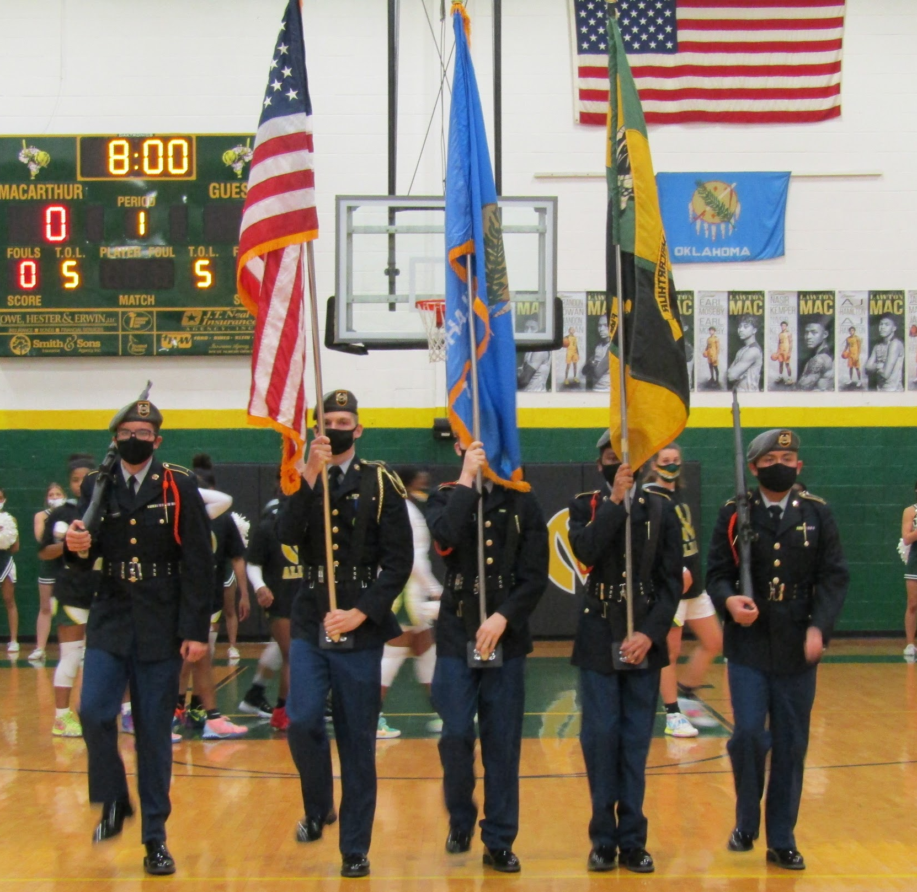
The UnArmed Drill Team performed for the halftime show on January 29th at the home basketball game against Ardmore.
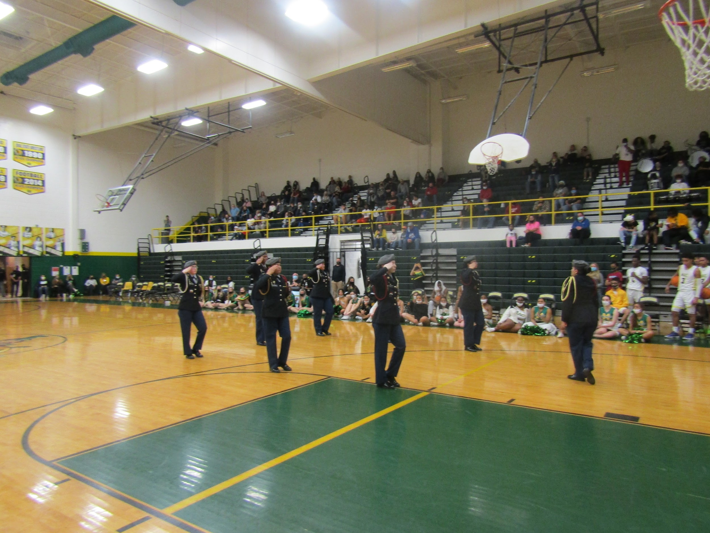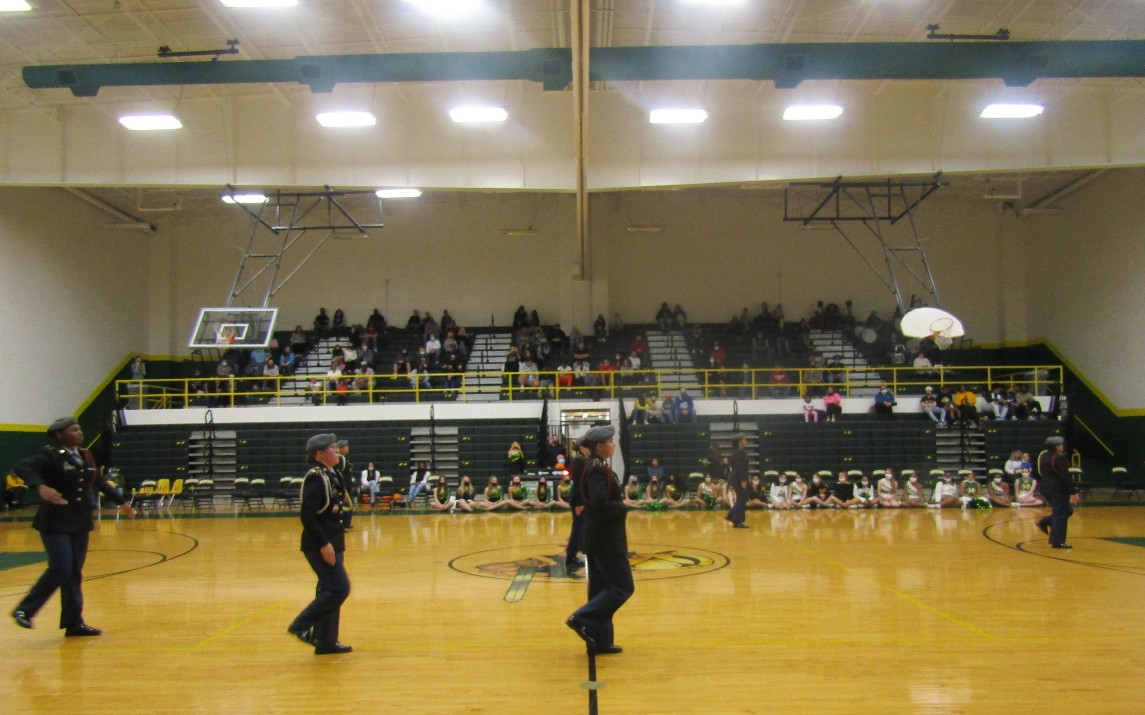
Cadet Highlights
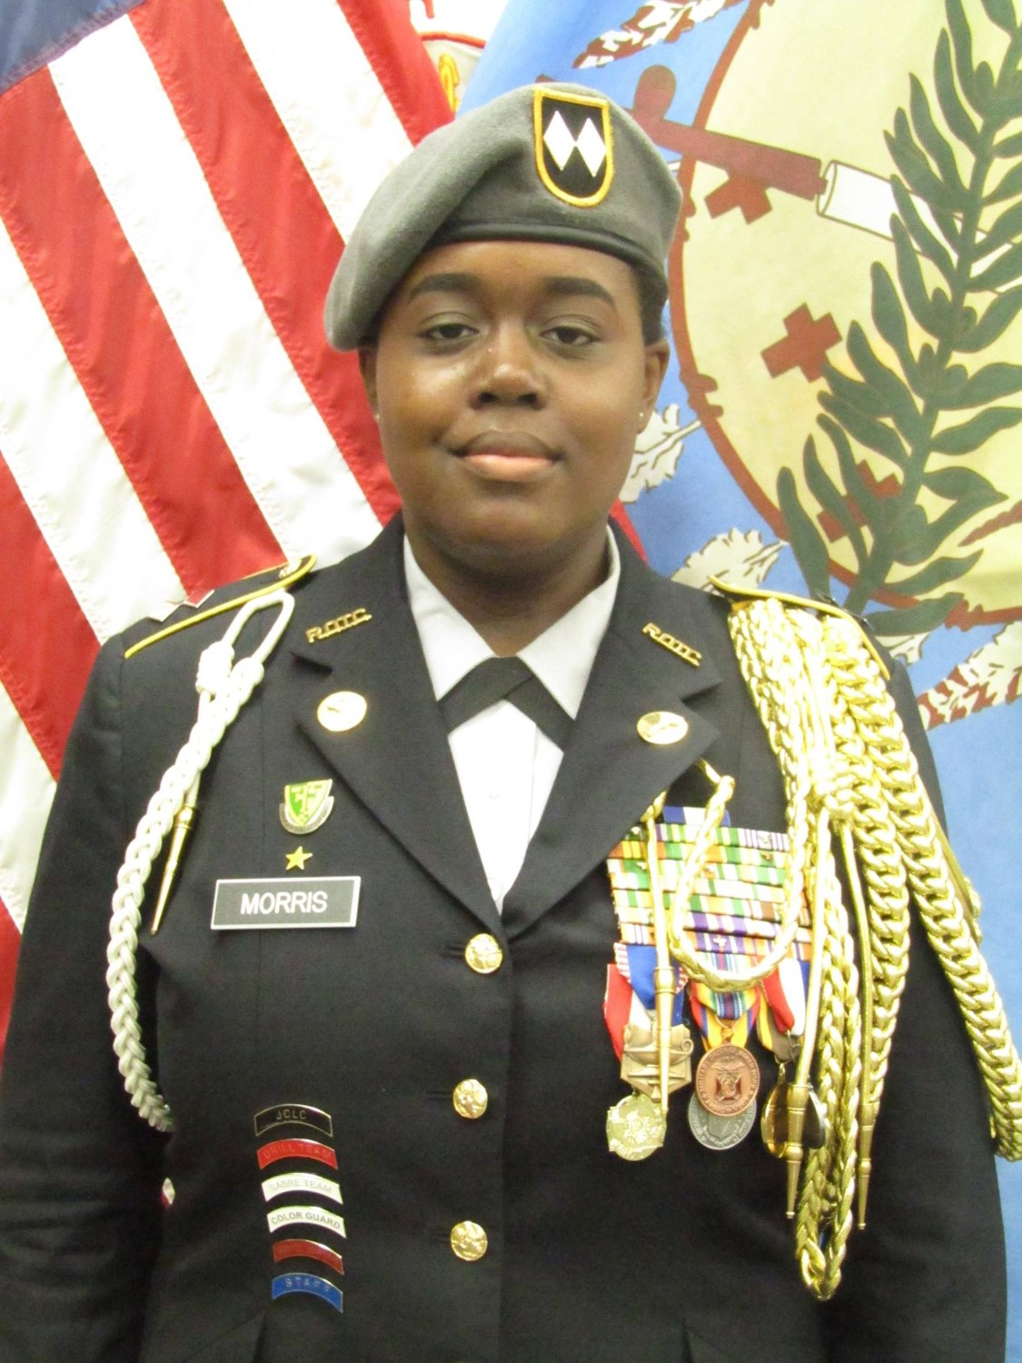
Cadet Lieutenant Colonel (LTC) Naschelle Morris is a Leadership Education Training Level (LET) 4 and the Battalion Commander of the program. She is the Varsity Color Guard Commander, a member of the Leadership Committee, Section Leader in Varsity Choir, and a Student Council representative. She is a senior and plans to attend Cameron University, majoring in Business and Criminal Justice while minoring in Pre-Law.
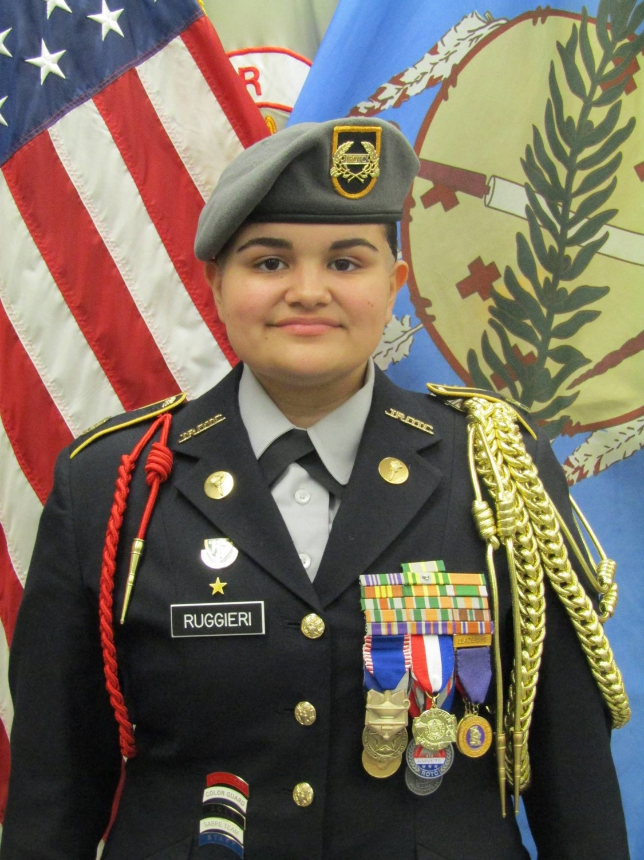
Cadet Command Sergeant Major (CSM) Bailey Ruggieri is a LET 4 and the CSM of the program. She is the Varsity UnArmed Drill Commander. She is a senior and plans to attend the Great Plains Technology Center to become a Phlebotomist.

We can’t wait to see what these ladies will accomplish in the next chapter of their lives. Make sure to congratulate them and wish them happy birthday. CSM Ruggieri will be turning 19 on February 1st and LTC Morris will be turning 18 on February 3rd.

