MacArthur JROTC Newsletter
March 2021
Article and photos by: Cadet Captain Jeslyn Hanza and Cadet SFC Addy Rosado
Hello cadets, we hope you are enjoying the second semester so far and staying warm during these cold times. This month the Color Guard team was busy performing for our home basketball games. On February 24, we held the 1st annual Leadership, Education, Training (LET) Level 1 Academic Bowl. Congratulations to the Echo Company Academic Team commanded by Cadet Corporal Kai Aguilar, consisting of Cadet Corporal Jamie Riha, Cadet Private First Class Jasmine Nobles, and Cadet Private Valerie Vazquez. They received 200 points toward their next promotion, a Gold Battalion Coin of Excellence, the gold Academic Team Cord, the gold Academic Team arc, the MacArthur JROTC Academic Team Torch of Knowledge Medal, a gift bag from the US Army Recruiting command, and the Academic Team ribbon for their uniform. 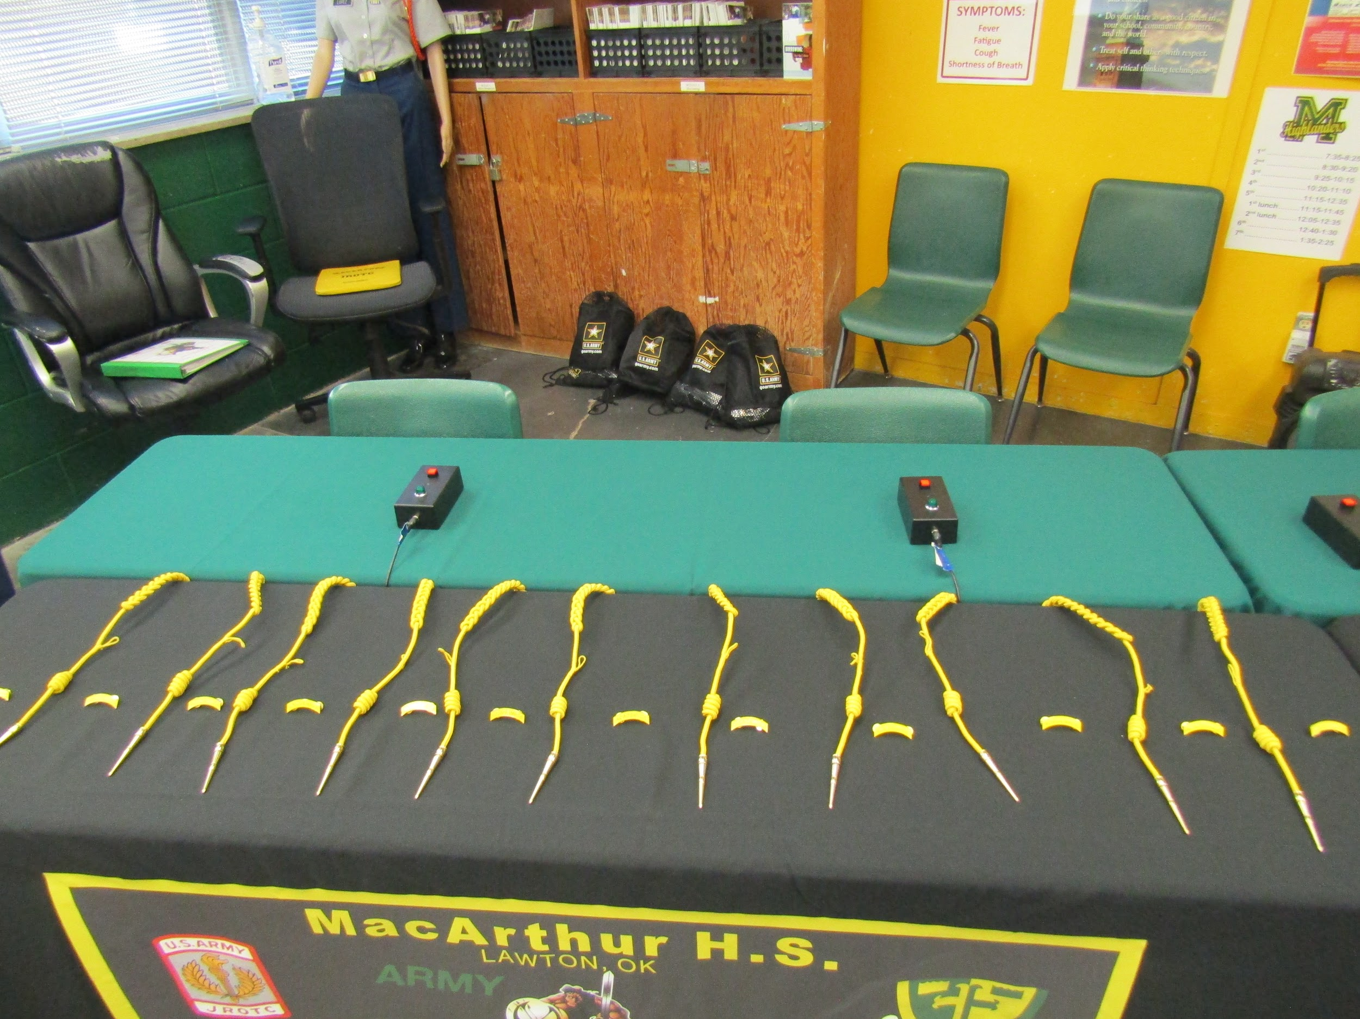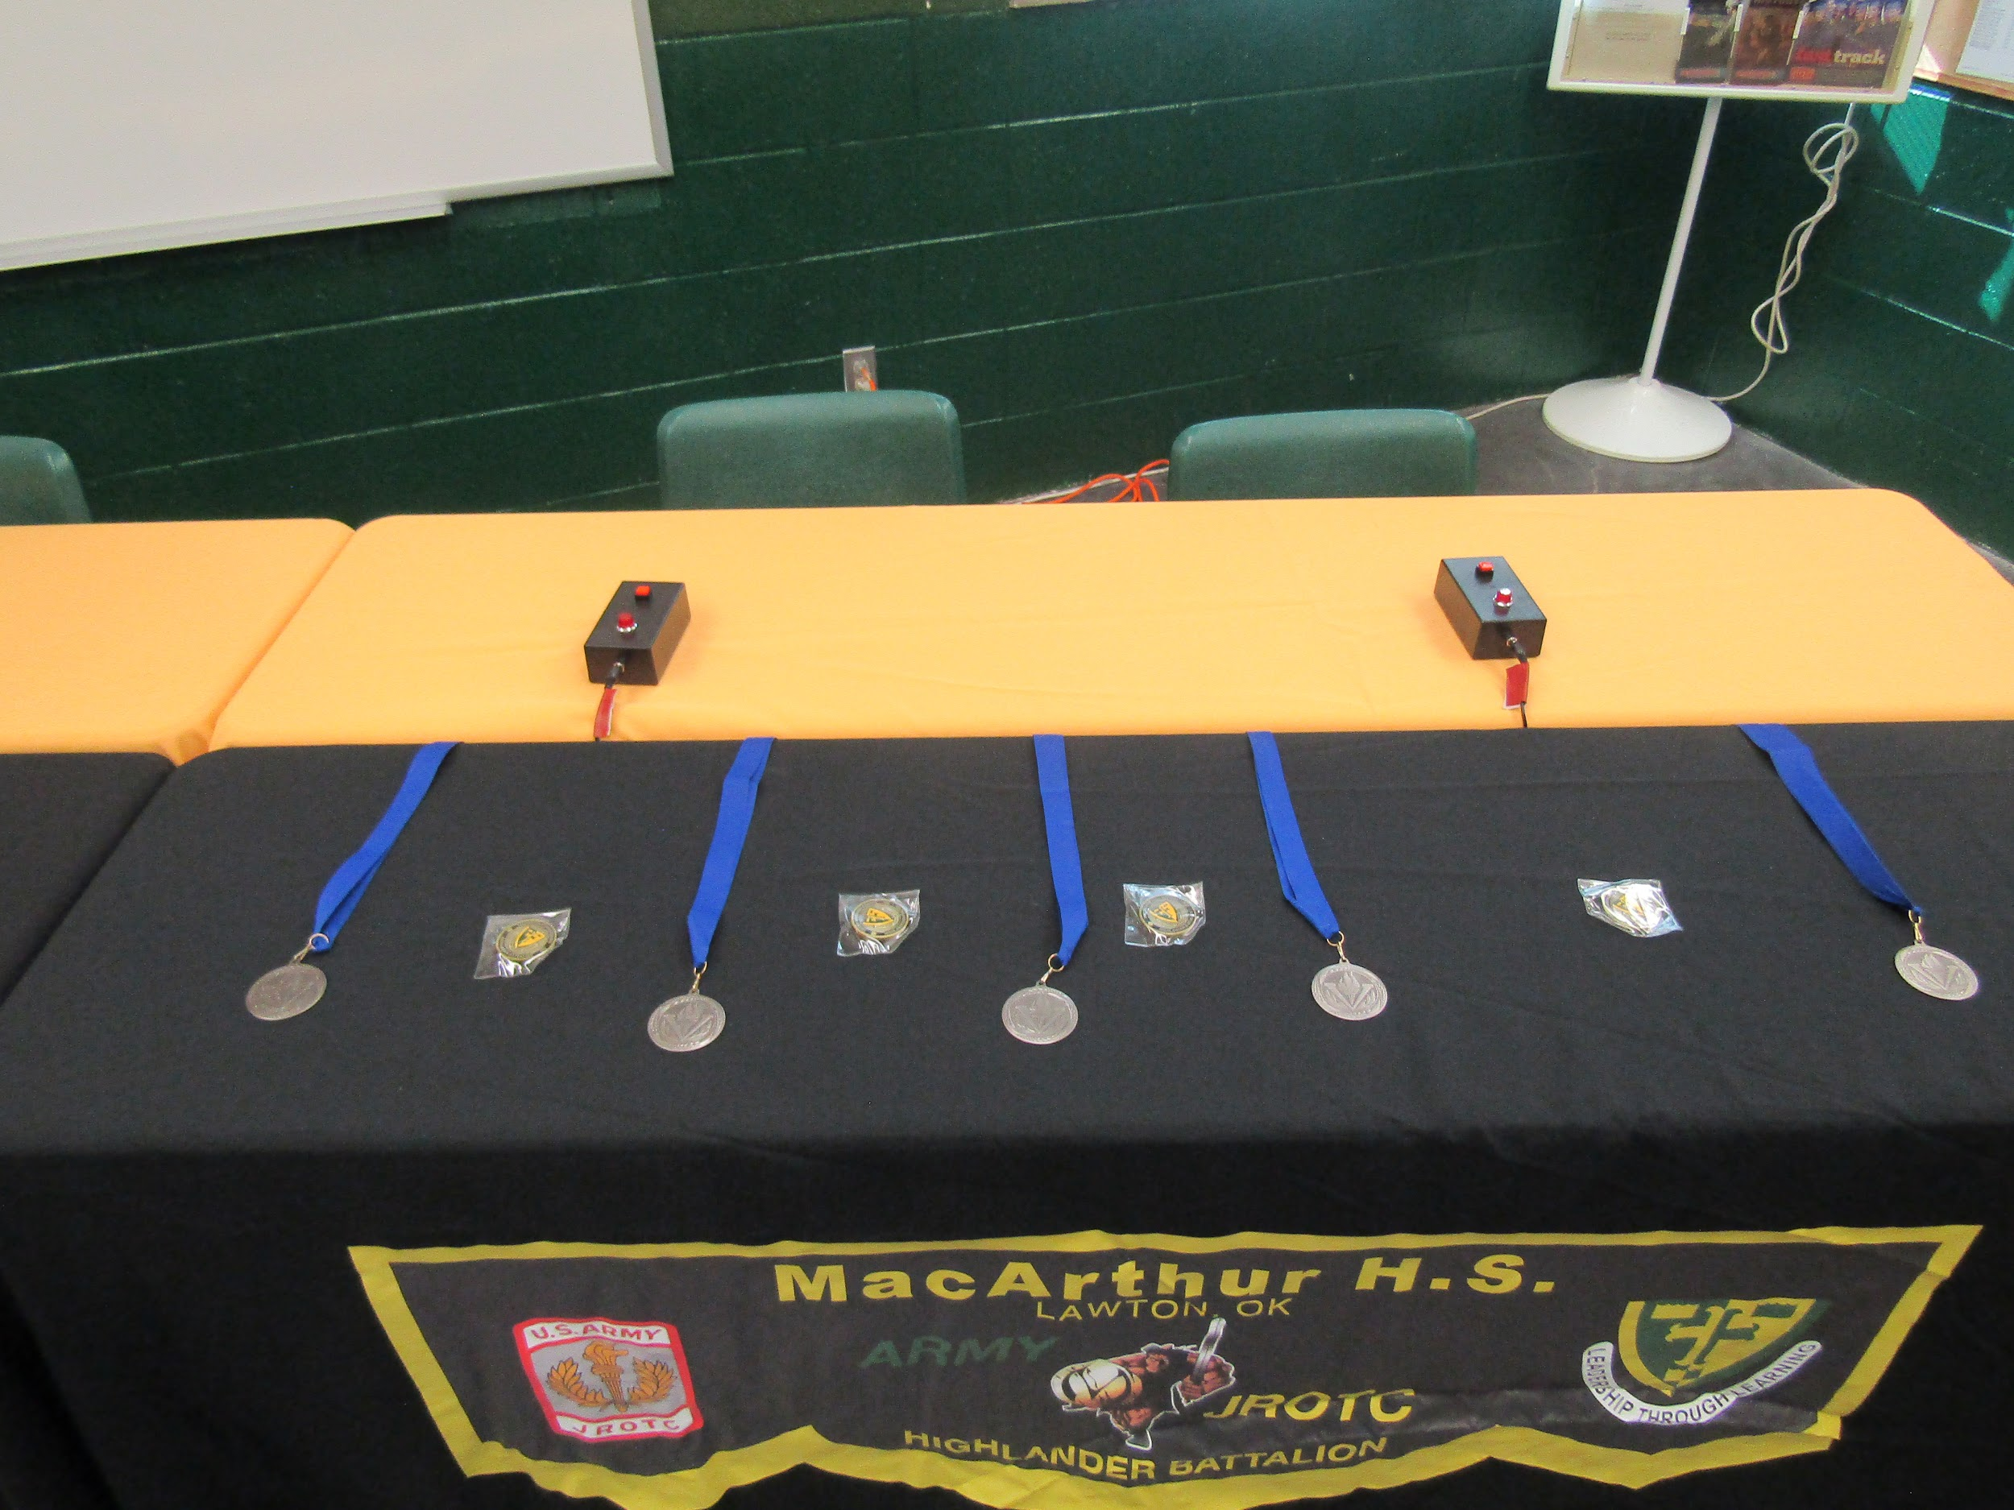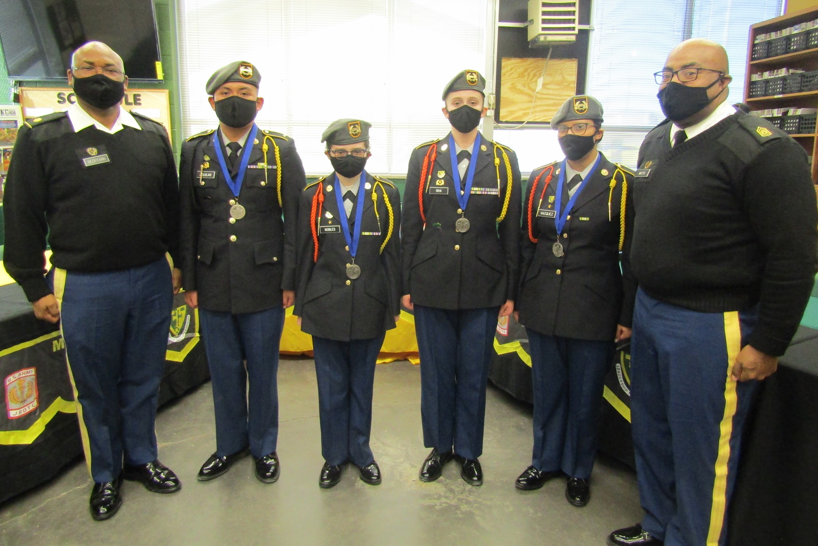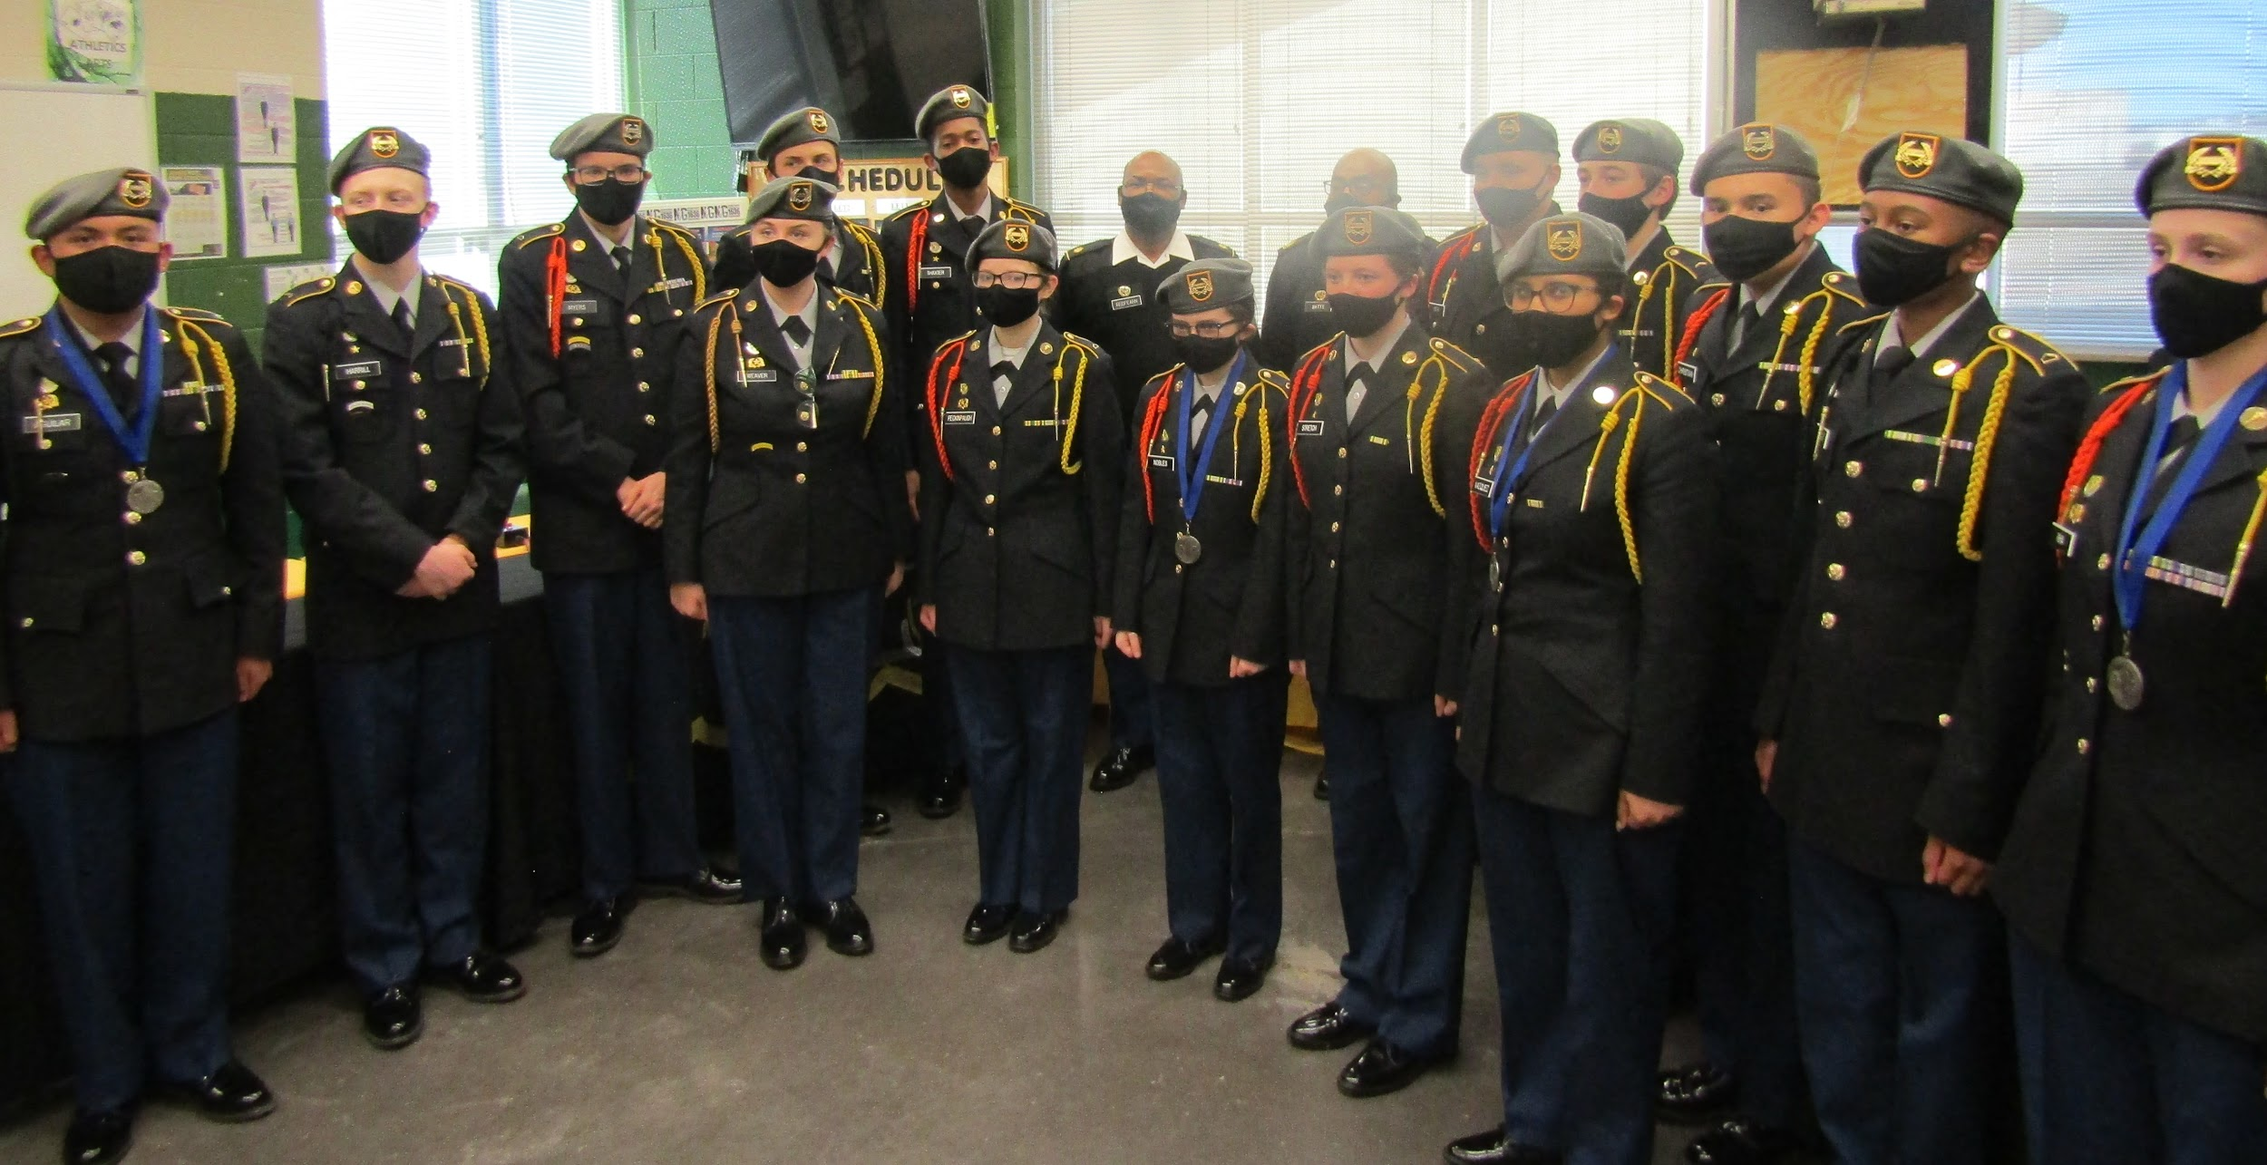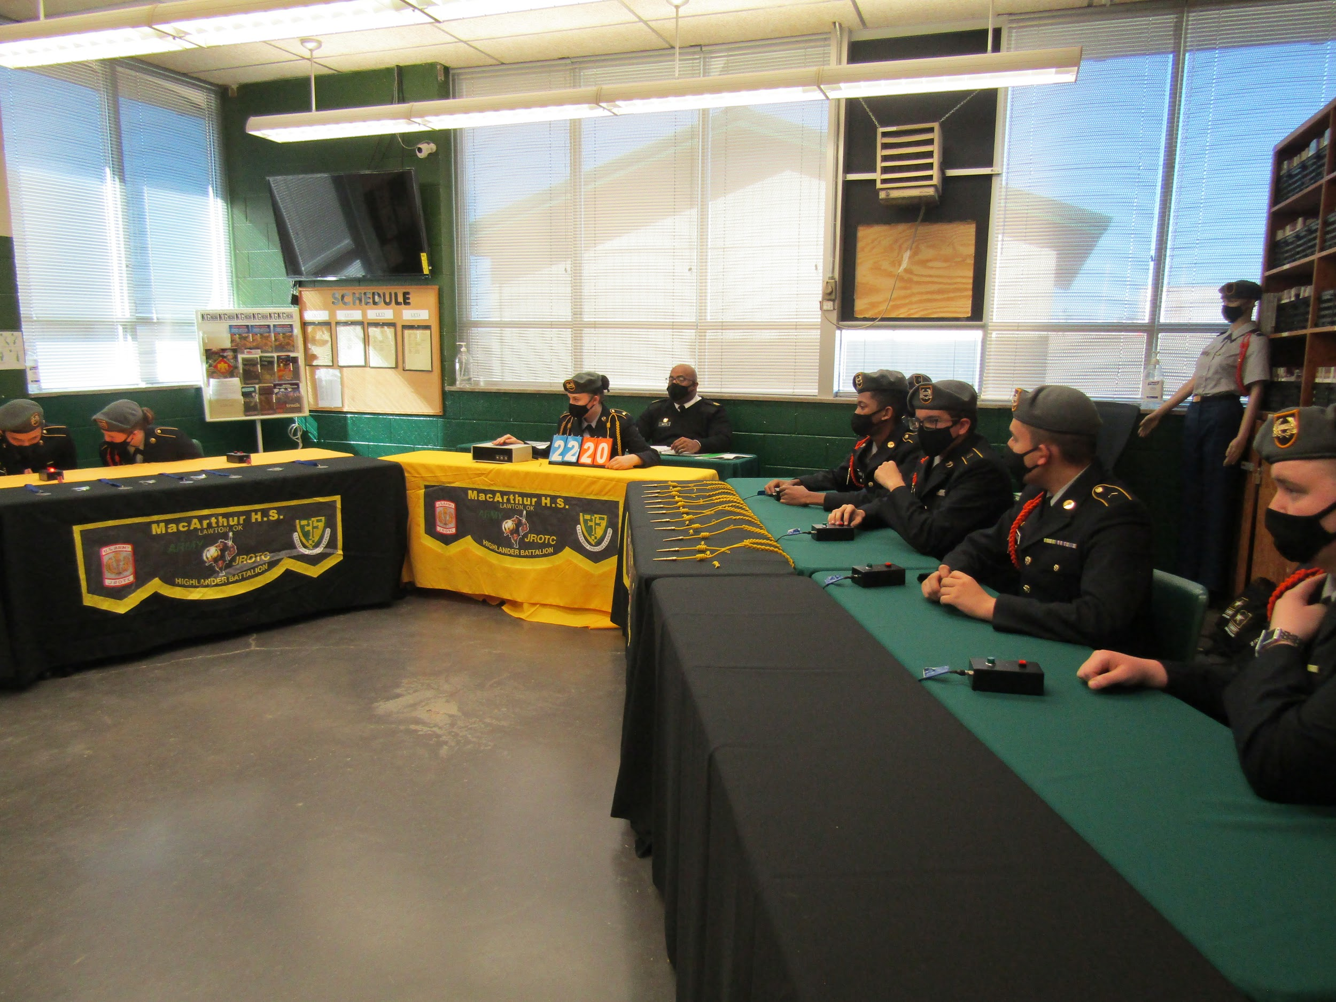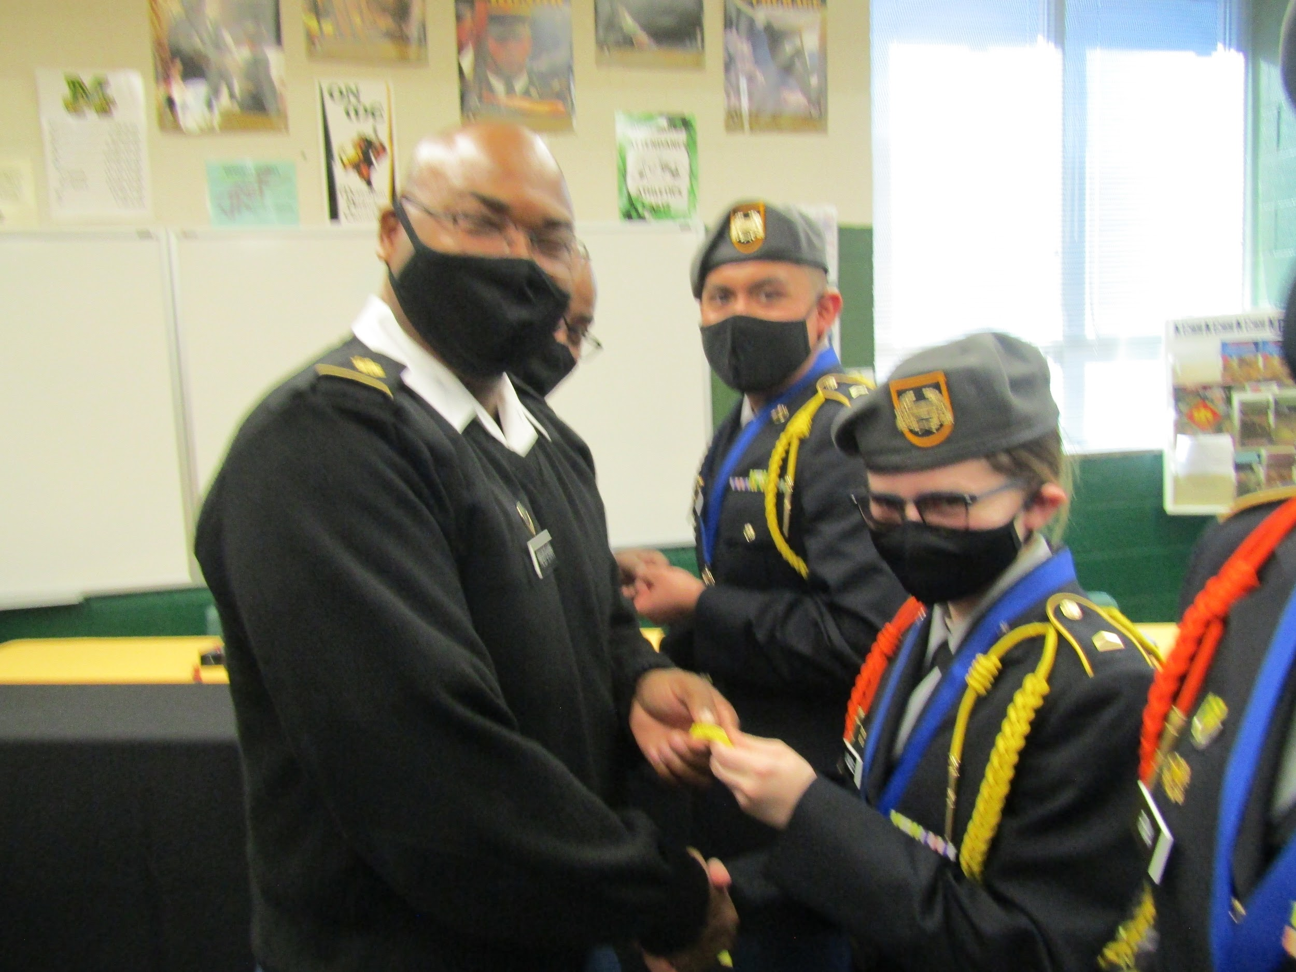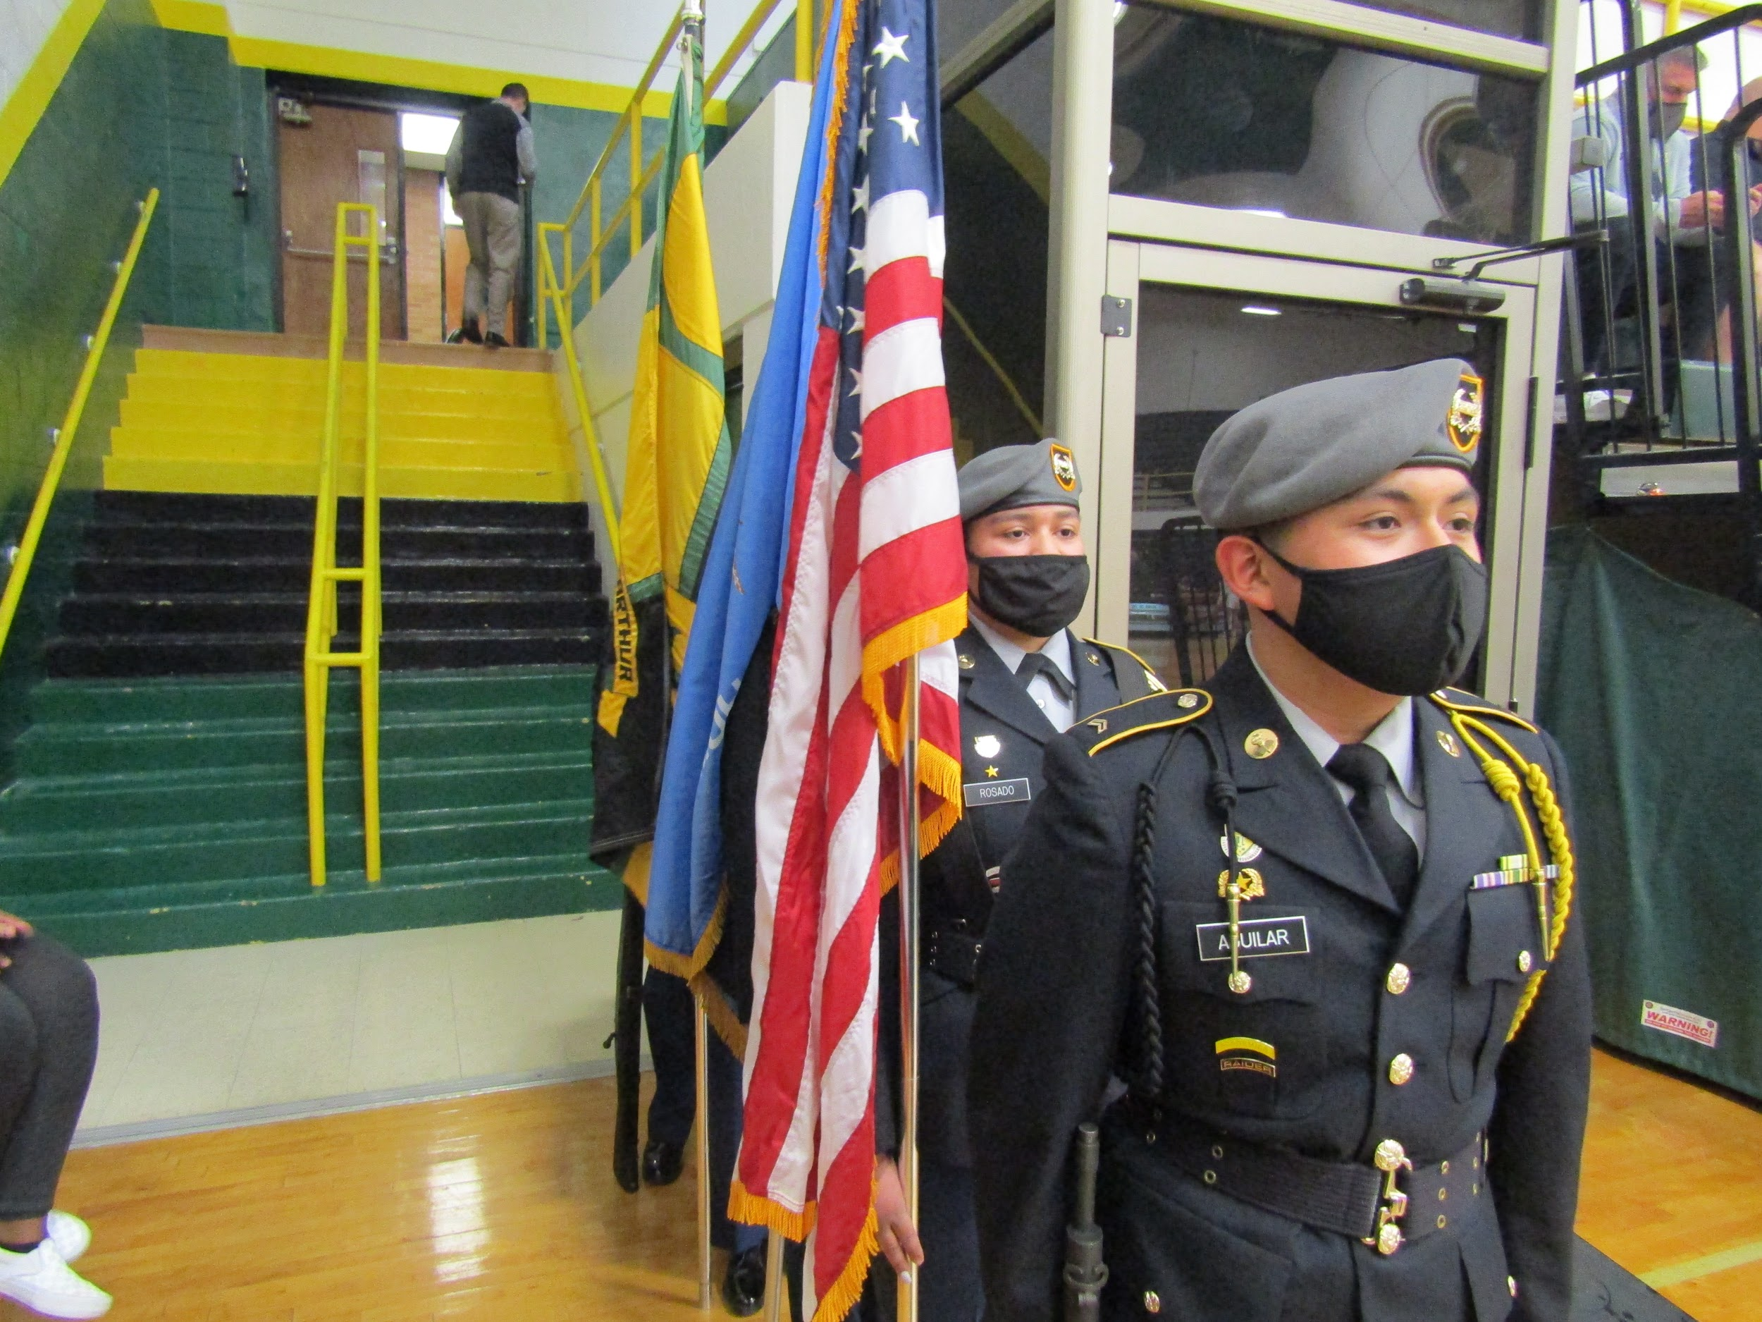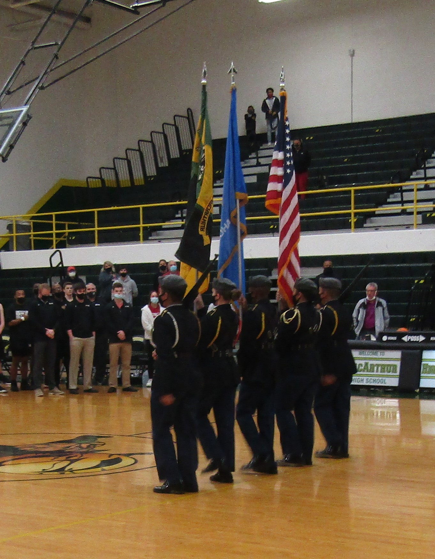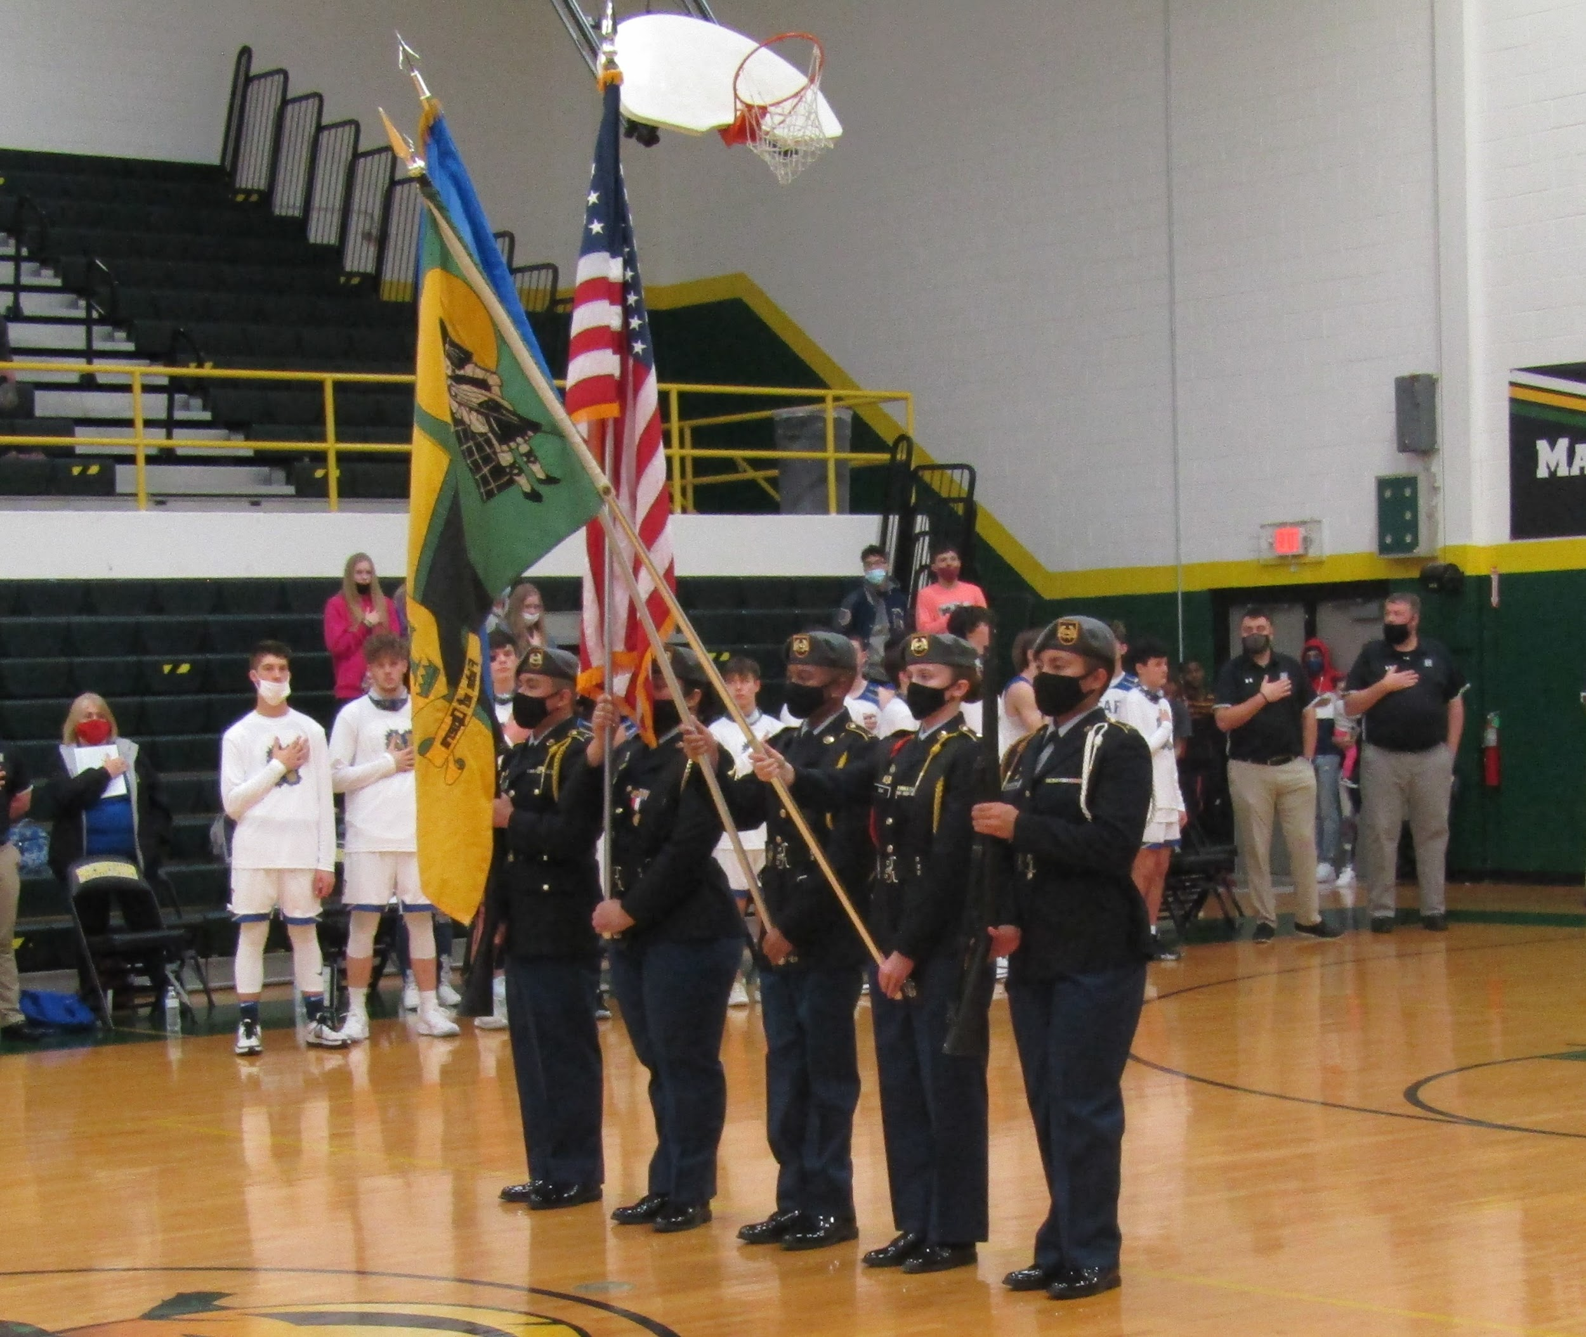

Upcoming Events
Friday March 5th 2:45 pm- Street cleanup
Friday March 12th 6:00 pm- JROTC Dining Out
Wednesday March 24th 2:35 pm-5:00 pm- Cadet of the 2nd Quarter Board
Friday March 26th 8:00 am-12:00pm- ASVAB Test
Saturday March 27th 4:30am-9:00pm- Drill Meet (Tulsa Union)

