MacArthur JROTC Newsletter
October 2020
Article and photos by : Cadet Staff Sergeant Jeslyn Hanza and Cadet Sergeant Addy Rosado.
Hello Cadets! We hope you are enjoying JROTC and all of your other classes so far this school year. We have done a lot of interesting things so far this year. In August, before school started, we held a Cadet Camp for incoming cadets to learn about JROTC for a week. They learned a lot and even earned their first rank for this. In September we were very busy with different events. We performed color guard, assisted with parking cars, and raised flags on the hill for all of the home football games. We also cleaned the stadium the morning following the football games that Macarthur hosted. We have sold coupon cards, boxes of candy, and conducted a car wash fundraiser this year. We collected $1,070 dollars at our Annual Car Wash this year. On September 26, we went to Hobart, our Color Guard led the parade while over 50 of the Battalion cadets marched behind for their celebration of freedom parade.
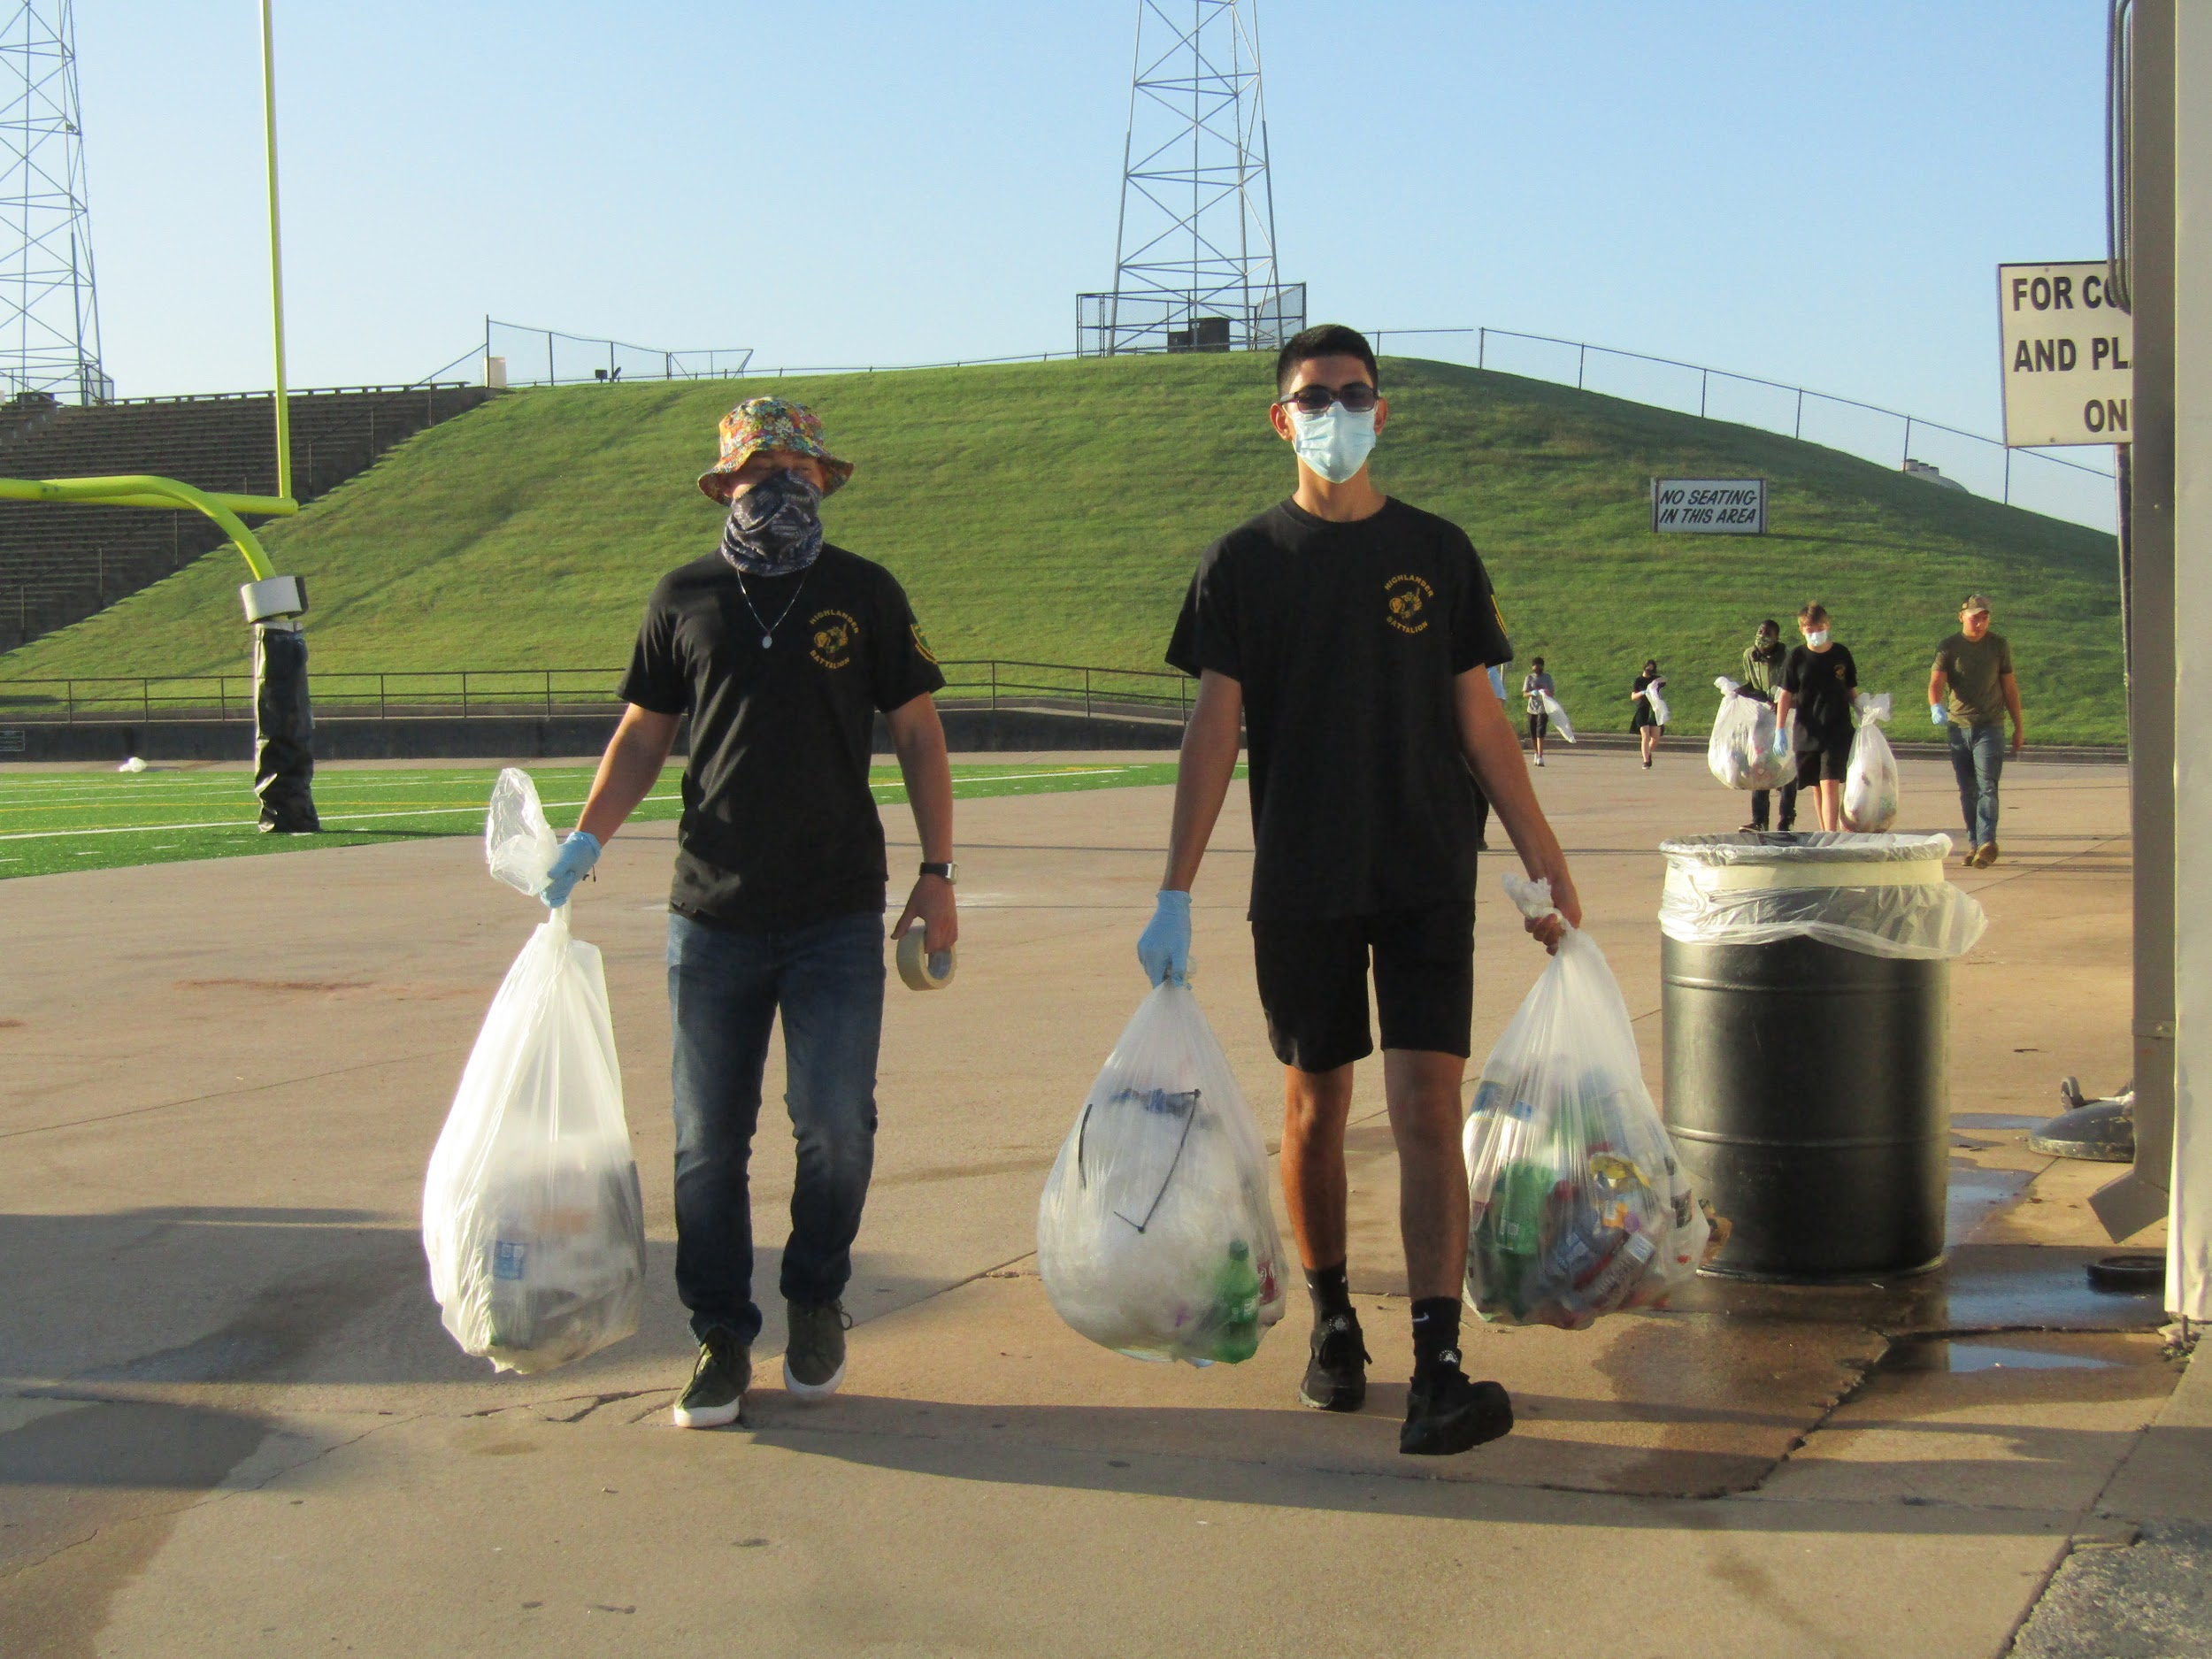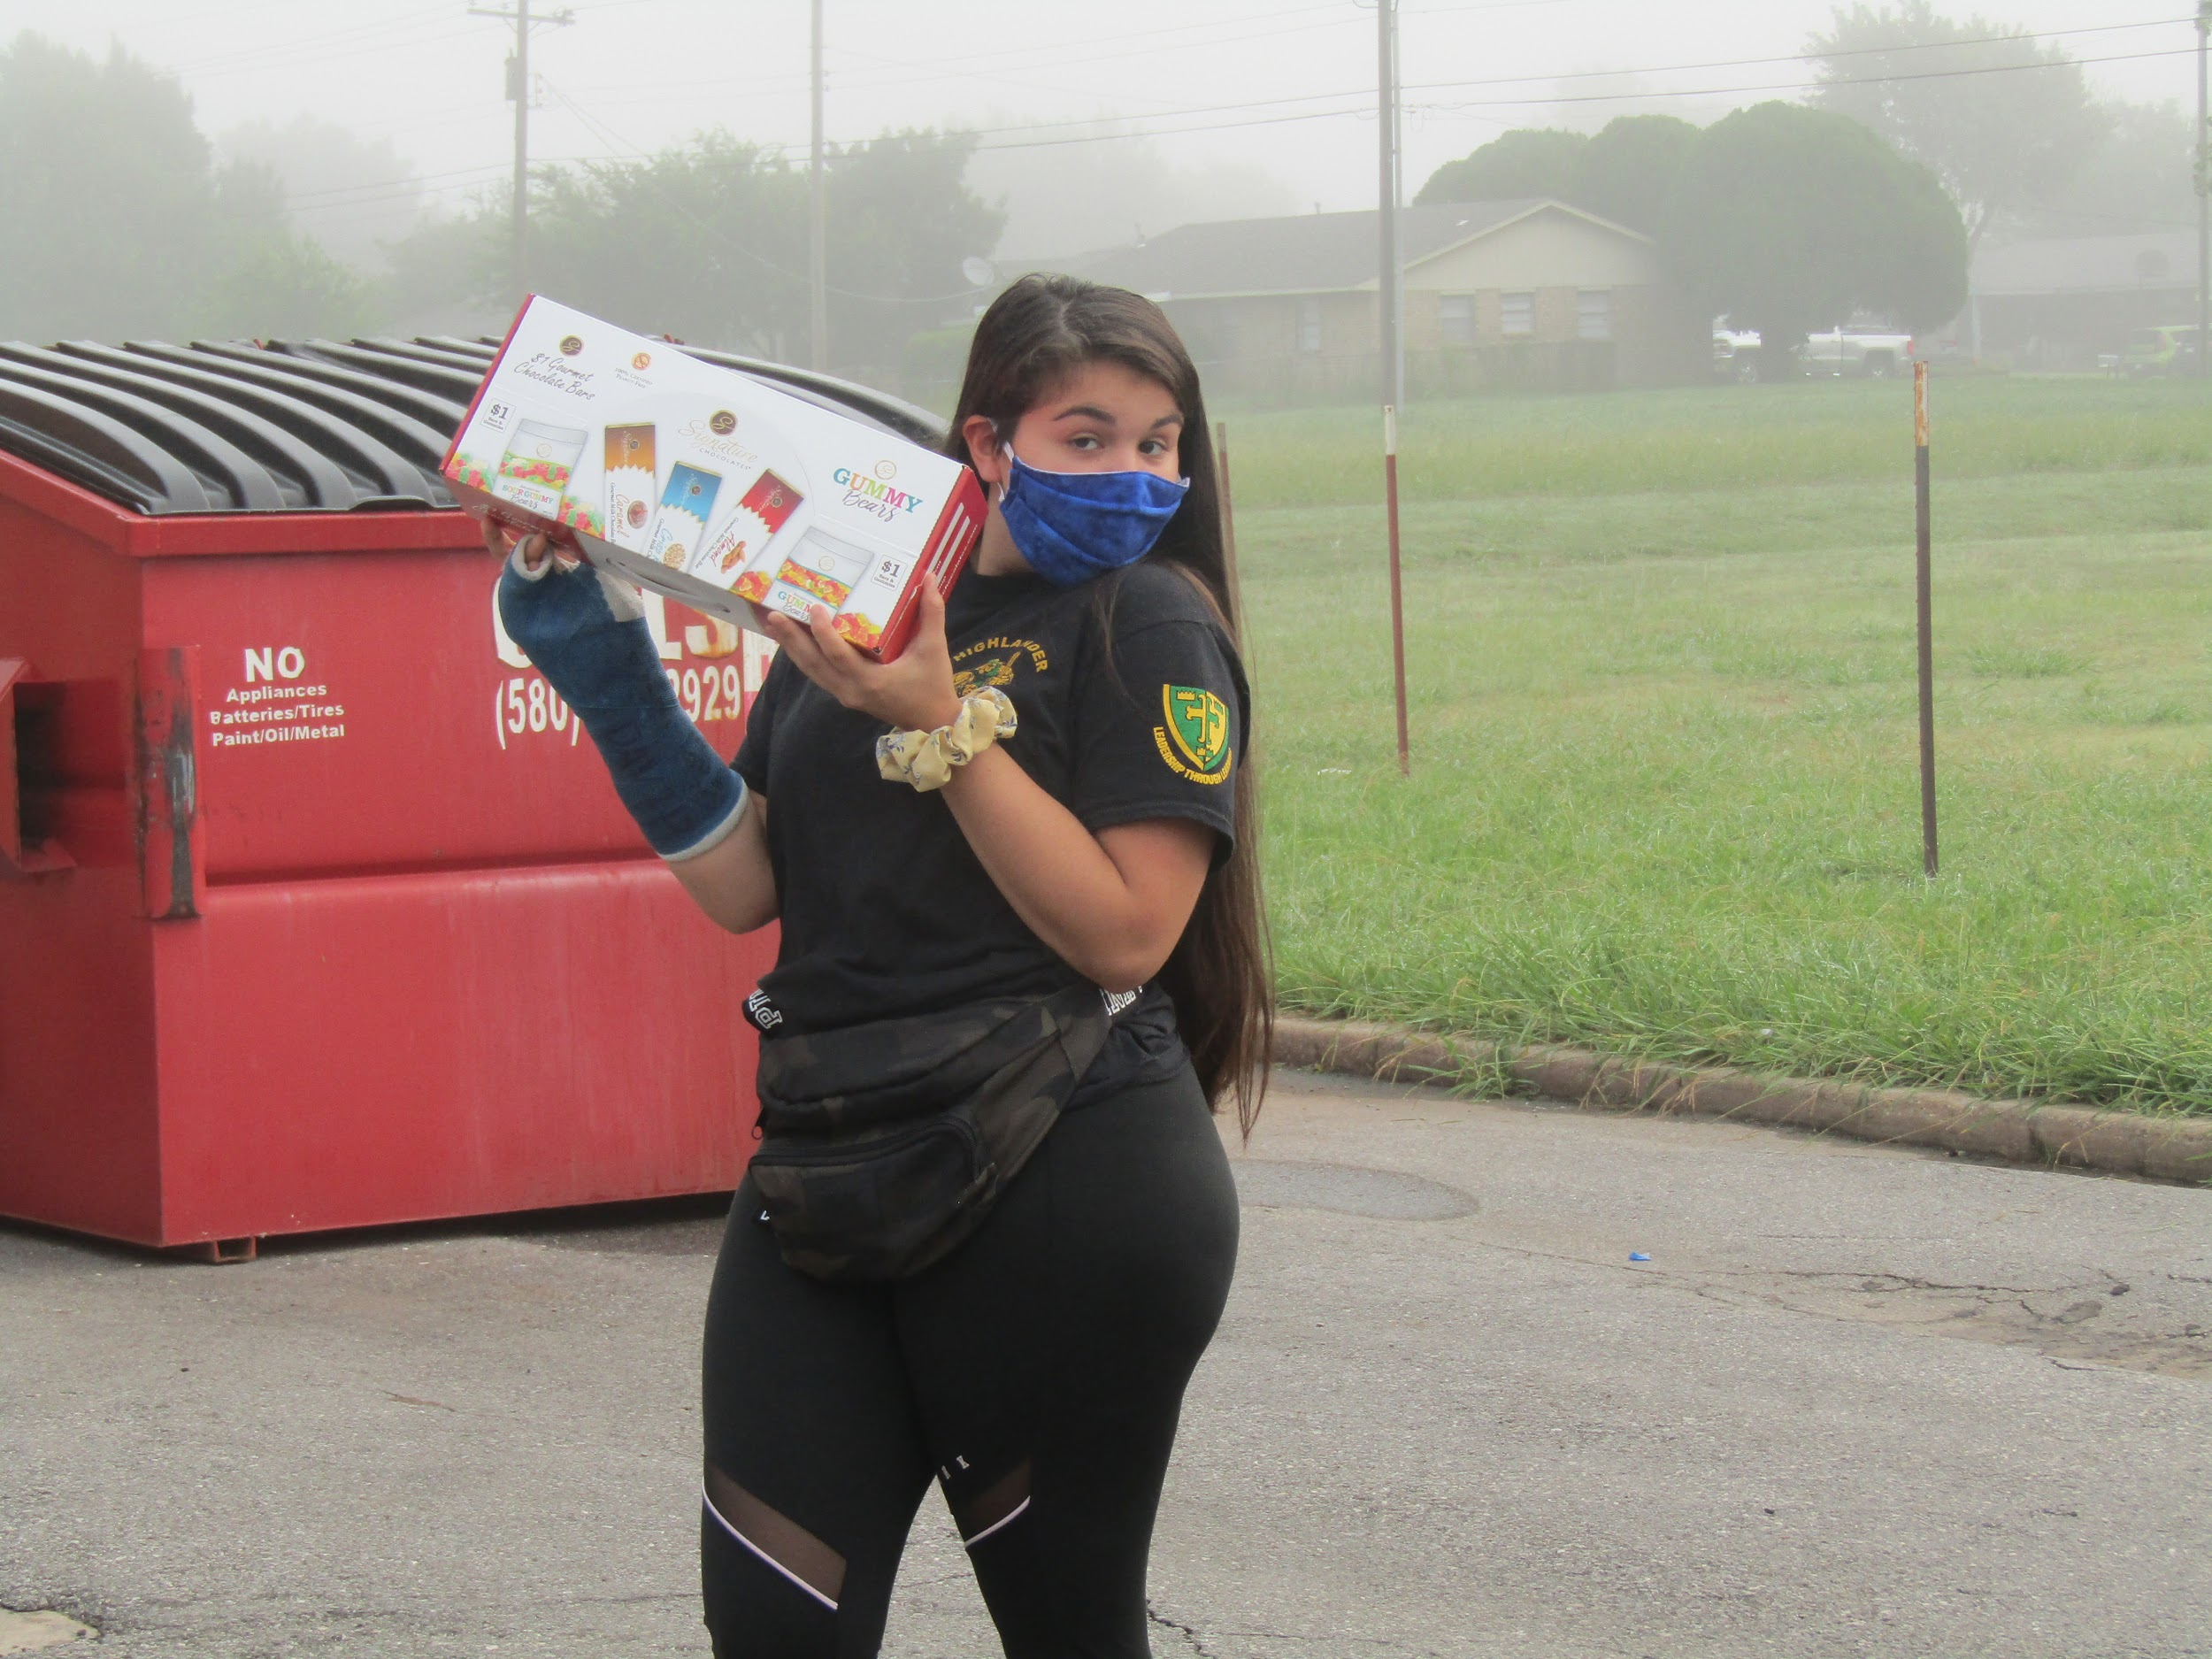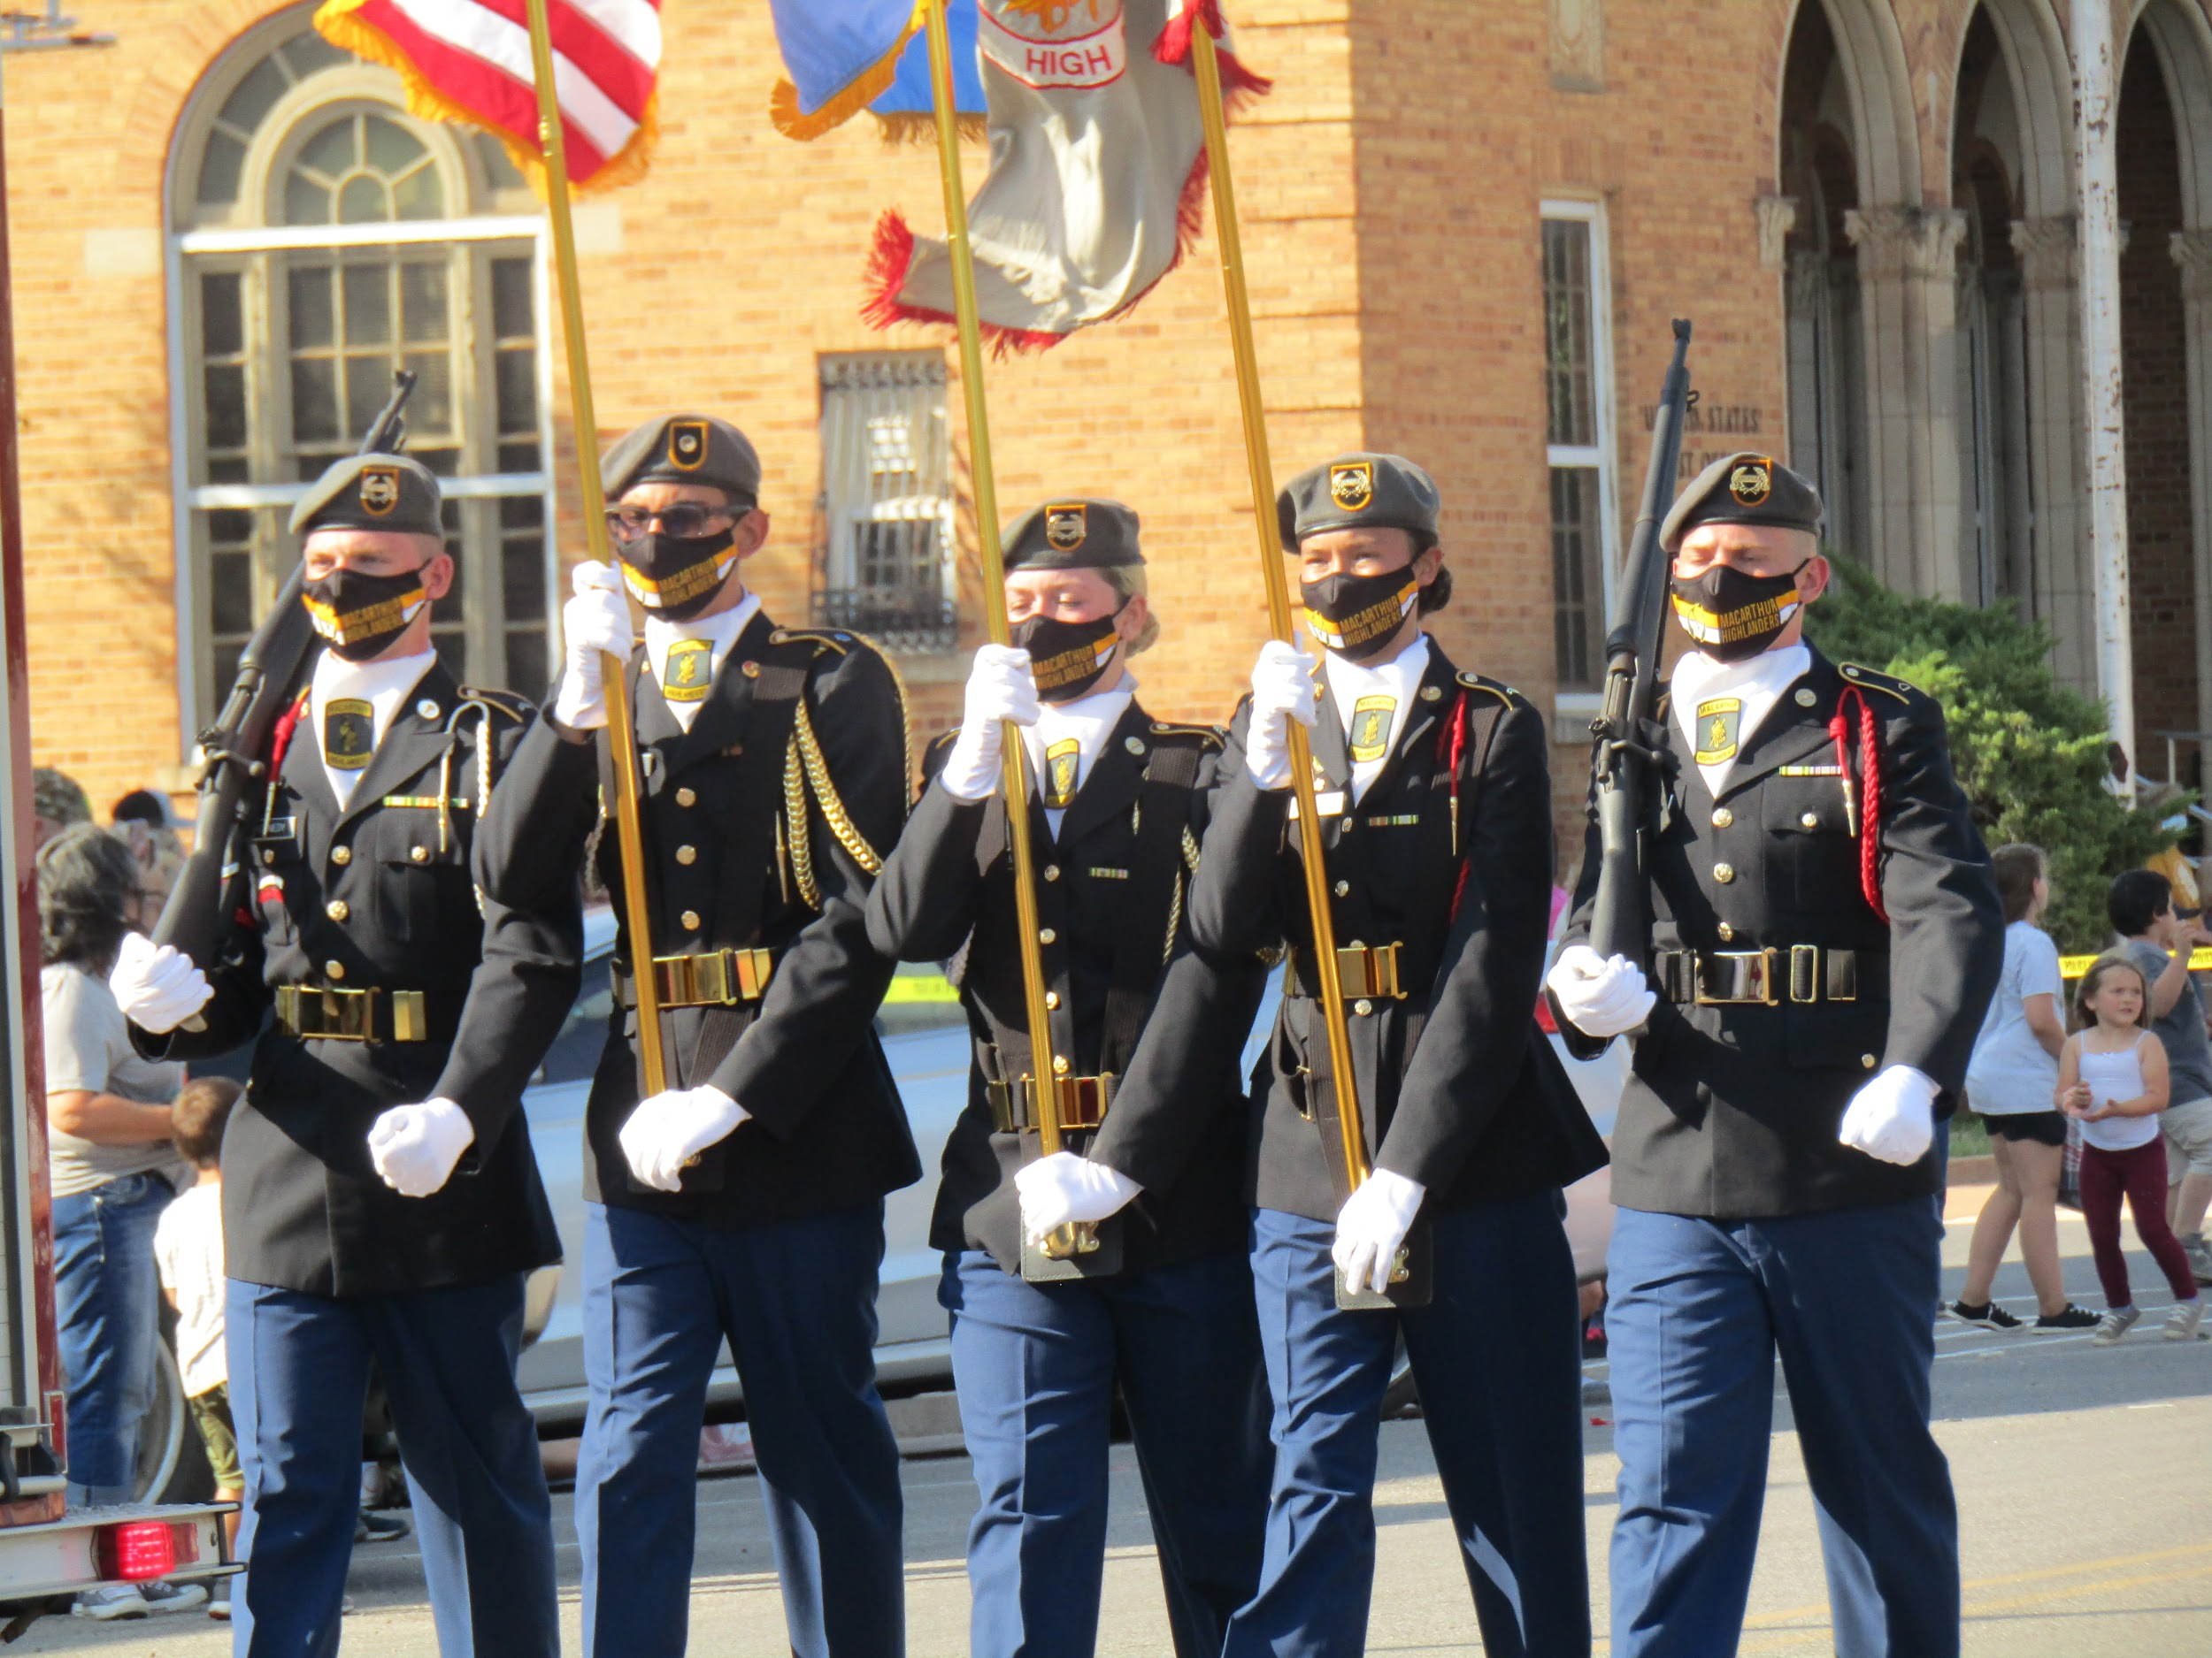

While we are very proud of what our cadets accomplish in JROTC, we also want to show what our cadets are capable of accomplishing outside of JROTC.
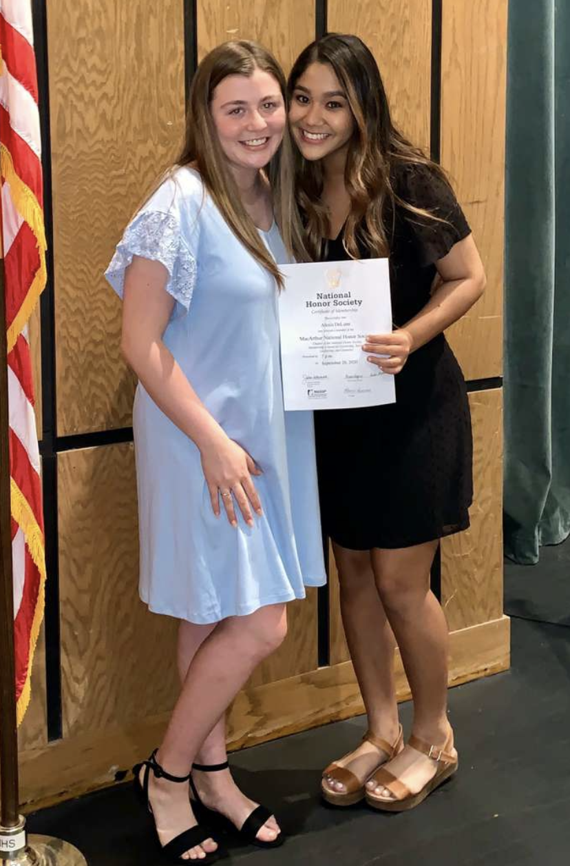
Cadet Private Jamie Riha (front left) is a black belt in karate. Karate has taught her a good work ethic, drive and discipline. Cadet PVT Jamie Riha is only a sophomore and we are so excited to see what she accomplishes in the rest of her high school career, inside and outside of JROTC.
Cadet Sergeant First Class Rachel Aguilar (left) is What is your favorite event
President of the National Honor Society. we have done so far this
She can handle the responsibilities year? What event that is
and the leadership that comes along coming up are you excited
with this position. Cadet (SFC) for? Let us know using the
Rachel Aguilar is a senior and is planning to pen and sticky notes to
attend Cameron University. We are so proud your right!
of her and cannot wait to see what she
accomplishes after graduation.
Cadet Corporal Alexis Deluna (right) is also a promising senior cadet who is also a member of the National Honor Society.

