PHYSICAL FITNESS WAIVER

Birdville ISD Military Skills Drill Meet
Statement of Waiver
For: Individual Physical Fitness Competition
In accepting the invitation to participate in the individual and team physical fitness event of the annual BISD JROTC Military Skills Meet, I, _______________________ (Print Name of Parent/Guardian), do hereby waive and release any and all claims against the United States Army, Birdville ISD, and the members of its JROTC Departments who are conducting the competition for any injury during the actual physical fitness event activity in conjunction with the conduct of the physical fitness competition.
_______________________________ __________ ___________________________
(Signature of Competitor) (Date) (Signature of Parent/Guardian)
ADDITIONAL INFORMATION: VERIFICATION:
__________________________________ / CSM Adams, Ronnie
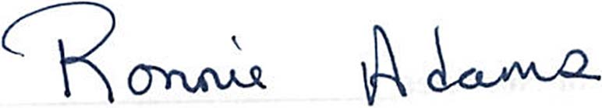
(Print Name of Competitor) (JROTC Instructor’s Name)
MacArthur HS / Highlander BN / _______________________
(Name of School/JROTC UNIT) (Instructor/Coach’s Signature)
_____________________________________, Lawton, OK 73507
(Home Address of Competitor) (City, State ZIP Code)
(Emergency Telephone Number)_______________________________
NOTE: Form must be completed and presented to the person in charge of the Check-in Point before your competitors are allowed to compete in the Physical Fitness Competition.

